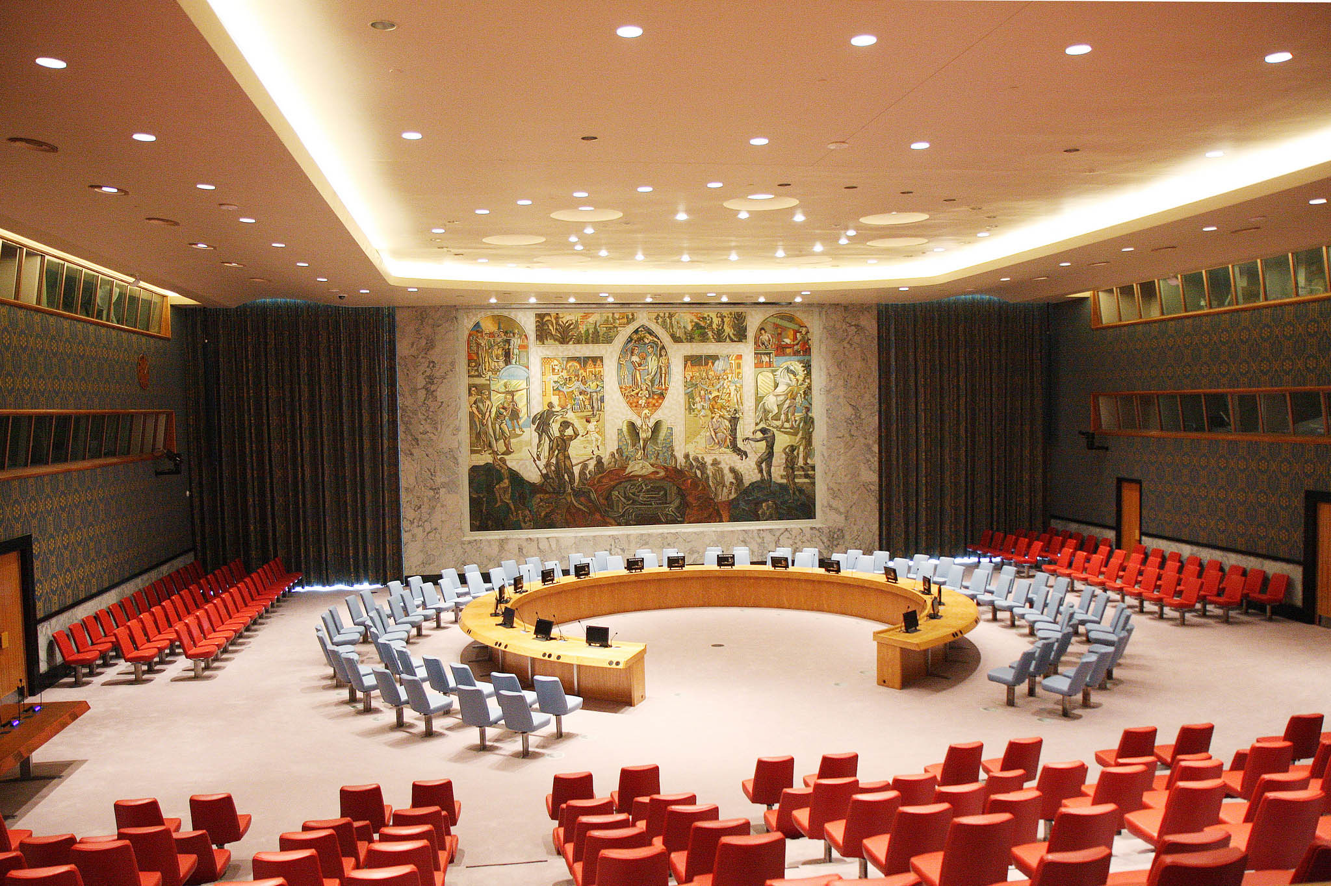
Security Council
TOPIC: Open agenda

SOCOMUN XXVI

Security Council
Hello, my name is Nicole DiNicola and I’m very excited to be your chair in the Security Council this year! I’m a junior here at SMCHS, and this is my third year being a part of MUN. MUN has been an incredibly rewarding experience that has allowed me to channel my love for public speaking through interesting debate with others who share my passion and goal to make a difference in the world. I have traveled to UC Berkeley and London, England for conferences, and I will be attending a conference in Prague, Czech Republic in January. Last year I was Secretary-General of SOCOMUN, and this year I am honored to be the Secretary-General of the SMCHS MUN program. Outside of MUN, I volunteer at a hospital, work in a special-education classroom, am a member of NCL, and compete on the school’s equestrian team.
As an open agenda Security Council, there will be no set speakers list. Speeches will go in alphabetical order by country and have no set speaking time. At our conference, we do not use moderated caucuses, so please be mindful to not motion for any. On the other hand, unmoderated caucuses are acceptable and can most definitely be motioned for. It is important to note that the 5 permanent members of the SC- China, France, Russia, the United Kingdom, and the United States- have veto power against any resolution. The open agenda will allow for the discussion of many different issues/topics that will be set by the delegates. Due to this, the topic synopsis being provided is a potential issue that may be discussed in committee (ISIS).
I hope that the conference will be a wonderful experience for all of you, and that you not only learn a lot and engage yourselves, but that you enjoy your time here as well. If you have any questions, please email socomunsc@gmail.com . I’m eager to meet you all and am greatly looking forward to committee! Good luck!

ISIS in the Middle East
Background:
The Islamic State of Iraq and Syria, abbreviated as ISIS, is composed of Sunni extremists who declared the establishment of a “caliphate” in 2013. The caliphate- a nation governed by Islamic law, also known as Sharia- has demanded that Muslims across the world swear allegiance to their leader Abu Bakr al-Baghdadi and relocate to the territories under its control. ISIS’ roots date back to an umbrella organization called the Islamic State in Iraq (ISI), which was created by the Iraq-based terror group known as al-Qaeda. Baghdadi assumed leadership in 2010 and carried out various monthly attacks in Iraq before he announced the merging of his Iraqi and Syrian forces in April 2013, which was due to joining the rebellion against Syrian President Bashar al-Assad. This joining of forces is what created the group now known as the “Islamic State of Iraq and Syria.” In June 2014, ISIS invaded and occupied the Iraqi city of Mosul and moved southwards towards the capital city Baghdad. After clashes with opposition groups, they took control of the Syrian city Raqqa. Raqqa has since then become the group’s headquarters and “capital city.” Within the areas that regions that the militants occupied, they massacred many of the ethnic and religious minorities.
Their established reign of terror has allowed for the institution of slavery and rape, as well as ethnic cleansing of Christians, Yazidis, Alawites, Shiites, etc. ISIS became notorious for their aggressive strategies of murder and torture, such as viral videos of beheadings, shootings, and the drowning and burning of victims. The group has been able to reach sympathizers all around the world through the usage of propaganda via social media, and have inspired “lone-wolf” terror attacks by those who glorify violence and swear their support to the caliphate. In March 2015, Quantum Communications researchers interviewed fighters to find the most common reasons for joining ISIS and other extremist groups. The results found that each reason showed that they were “seeking” something: some sought to improve their social status, find their own identity after feeling isolated/alienated, sought revenge, redemption, responsibility, thrill, ideology, death by martyrdom, and “justice.” Studies of western-based affiliates displayed that the most common reason for swearing allegiance to ISIS and other terror groups was to receive personal recognition.
In October 2015, the group claimed responsibility for the placement and detonation of a bomb aboard a Russian airliner that had departed from Egypt. A month later, suicide-attackers carried out attacks across Paris that killed around 130 people. Numerous other attacks have taken place in cities such as Ottawa, Sydney, Ankara, Istanbul, Orlando, and many others. The attacks outside of ISIS-controlled regions have been directed at westerner’s, Hindus, Jews, Shiites, homosexuals, and essentially any person or group that disagrees with the caliphate or has been deemed as “infidels.” Oil extraction is known to be the Islamic State’s largest source of income, and the group sells crude oil to truckers and middlemen at a well-below market price. Due to the cheap prices, traders are incentivized to purchase from them. Moreover, another source of income come from the taxes that they enforce in the territories under their control, and ransom payments provided the group with an estimated $20 million US dollars. The presence of the terror group and the ongoing instability that has shaken the Middle East for many years has led to a major refugee crisis that is currently at its peak. The violent extremism exhibited by the IS has alarmed the United Nations and has prompted many of its committees to discuss and find solutions to the issue. On November 20^{th,} 2015, the Security Council (SC) condemned ISIS attacks and adopted texts that determines the group poses an ‘unprecedented threat.’ The SC also adopted S/RES/2253 on the 17th of December 2015, which directs the Monitoring Team to submit reports on the global threat posed by ISIS and other affiliates, and extends their control over the issue. Moreover, committees such as DISEC and Ad Hoc on Terror have contributed to the brainstorming and drafting of resolutions regarding the IS, and many humanitarian committees such as the UNHCR, UNODC, and UNICEF have contributed to the refugee crisis.

Possible Solutions:
The following solutions could be implemented to help solve the issue that is the Islamic State, however it is incredibly important that you think of your own solutions and work with other delegates to improve them and use them in resolutions. It is imperative that your country stays on policy when creating resolutions (ex. it would be highly unlikely that Russia would support any resolution that interferes with the Assad regime in Syria). Also, funding for solutions and programs is not an issue for the Security Council and is therefore addressed in the Fifth Committee and World Bank.
One possible solution regarding the transportation of people and goods may encompass increased number of inspections on aircrafts, vehicles, sea vessels, and other modes of transportation. Boarding agreements should be put into place that would provide authority on a bilateral basis to any potential transfer of ISIS affiliates and weaponry. An immediate solution to this may include a blockade of Highway #80, which goes into Mosul. A military blockade would ensure that no one can enter through these roads, which is crucial considering they are the only roads that connect Mosul to other ISIS-controlled territories. Military personnel from nations willing to put troops on the ground would be provided (whether they are Iraqi forces, western forces, etc.). Stricter border control should be enforced in cooperation with governments, organizations, and UN committees such as the International Criminal Police Organization (INTERPOL). Aside from strengthening military forces and providing advanced surveillance technology, INTERPOL would ensure that governments destroy excess stocks of materials that terrorists can use to create weapons of mass destruction. Any government that resists destroying the materials would be penalized. Moreover, factories and resource producers should have increased security and surveillance to ensure that ISIS affiliates cannot obtain materials and weaponry.
The implementation of social media campaigns to counter ISIS’ recruiting methods could be effective in preventing people around the world from joining their cause. Social media and counter-propaganda experts would be of assistance in combatting online advocates of extremism. International collaboration for digital security can come through transparency and sharing resources like security personnel and information to fight online terror-related propaganda. Moreover, the establishment of a database would be useful for ensuring transparency among nations and providing background on potential terror threats and activities. Regarding reconstruction, it is important to note that political compromise, financial assistance, quality of life, employment, and economic opportunities must be provided to civilians of affected regions to better prevent them from resorting to terror organizations. A summit should be held in a country willing to host diplomats and humanitarian activists (ex. Washington DC, London, Berlin, etc.) to discuss aid to the civilians in affected regions and how to further handle the refugee crisis. The SC sponsors of S/RES/1373 must further implement the counter-terrorism measures called for in the resolution, such as condemning states that sponsor terrorism, encouraging governmental cooperation, working to cut off terror groups from their financial resources and sources of revenue, and criminalizing anyone who affiliates with a terror organization. Through the usage of the UNHCR, the implementation of vocational programs would provide refugees with information needed to seek opportunities regarding education, reintegration, and reparation.
Cooperation and the renewal of ties between nations such as Saudi Arabia and Afghanistan would be very beneficial in the prevention of further emersions of terror groups. NATO facilitation would be useful to prevent Taliban and al-Qaeda influence and resurgence, and would also provide financial and military aid. It is important to note that military force against ISIS cannot be completely ruled out, as diplomatic strategies may only be successful for so long. Any kind of military action must be mindful of civilians and environmental hazards to prevent meaningless and unnecessary loss of life.

Questions to Consider:
These questions are not meant to be directly answered and addressed in committee, however they are provided to assist delegates with research on background, UN involvement, country involvement, and solutions:
1. What measures has your country taken in the fight against ISIS?
2. What are some viable solutions to ISIS’ use of social media? How can countries intervene with/prevent their recruitment through media?
3. How does your country suggest the international community deals with the weaponry that ISIS holds? How can we prevent them from receiving more (ex. cutting finances?)
4. What solutions has the United Nations already implemented?
5. What’s the diplomatic strategy against radical jihadists? Is fighting on the battlefield the only option?
6. For countries where the citizens have vast civil liberties (ex. USA, UK, etc.), how can civil liberties and surveillance for safety be balanced?
7. Particularly for any solutions regarding military action/violence, how should the question of refugees be addressed?
8. How should the international community combat the issue of future reconstruction in regions taken over by ISIS?
Works Cited
Barker, Anne. “How Islamic State’s impact has gone global.” ABC News. Abc.net.au, 23 Mar. 2016. Web. 26 Mar. 2017. <http://www.abc.net.au/news/2016-03-16/islamic-state-isis- global-impact/7089664>.
This resource effectively highlights the global impact of ISIL. It provides several examples of ISIL attacks and ISIL-influenced incidents in several nations of the world. While not incredibly detailed, it does help layout those nations that are directly involved in this situation. Using this information can really help a delegate determine their country policy in this conflict. As a delegate, country policy is by far the most important aspect of an individual’s understanding of a conflict. By providing specific examples of their country’s involvement in a conflict, a delegate can easily stand out in committee, and it makes their life easier while debating.

Cockburn, Patrick. "Who are Isis? The rise of the Islamic State in Iraq and the Levant." The Independent. Independent Digital News and Media, 16 June 2014. Web. 06 Apr. 2017.
This article discusses the Islamic State of Iraq along with ISIS and how they operate with such brutality across central and northern Iraq. The article also talks about Abu Bake al- Baghdadi who has been a leader since 2010. It provides unbiased information as it just states facts about ISIS operation and its leaders. Such a resource is helpful when trying to understand the group itself.

"How Did the Islamic State Capture Raqqa?" Fort Russ. N.p., n.d. Web. 27 Apr. 2017. <http://www.fort-russ.com/2016/03/how-did-islamic-state-capture-raqqa.html>.
This article explains how ISIS came to control its “capital city.” It is very important to understand how ISIS operates its capital as it can lead intelligence to lots of information regarding finance, future plans, military strategies, major leaders, etc. Moreover, it helps provide more information on how ISIS uses certain strategies to take over cities

"ISIS Storyline" NBCNews.com. NBC Universal News Group, n.d. Web. 15 Apr. 2017. <http://www.nbcnews.com/storyline/isis-terror>.
This source provides all up-to-date articles regarding ISIS, including recent attacks and general news on the group. Additionally, it includes background articles as well as opinionated articles (if you are seeking them) to provide different perspectives and understandings on the issue. Understanding different perspectives on an issue will prepare you to deal with delegates whose nation’s share a different policy than yours.

"ISIS: Timeline of the Rise of the Islamic State." Time. Time, n.d. Web. 16 Apr. 2017. <http://time.com/4030714/isis-timeline-islamic-state/>.
This timeline of ISIS operations addresses the terror group’s rise, occupation, and attacks they have carried out. It is very helpful to see a timeline of events because not only does it allow you to gain a better concept of time, but it lays out events in a very organized manner. This allows for easy comprehension and extraction of given information.

“Islamic State and the crisis in Iraq and Syria in maps.” BBC News. World News – Middle East, 20 Jan. 2017. Web. 26 Mar. 2017. <http://www.bbc.com/news/world-middle-east- 27838034>.
This source covers the background of ISIL and the advances they have made in the Middle East through a series of visually appealing maps and charts. They help visualize critical data that are important to the research of ISIS. This resource comes from a credible news organization over in Europe. This helps provide a different perspective on the conflict from another part of the world. Overall, however, this gives the same information as other sources. However, this source is more accurate than others, as it provides more current information. This relevance is most important in MUN, and especially in the Security Council.

Laub, Zachary. “The Islamic State.” Council on Foreign Relations. CFR Backgrounders, 10 Aug. 2016. Web. 26 Mar. 2017. <http://www.cfr.org/iraq/islamic-state/p14811>.
This source covers a general background of the Islamic State of Iraq and the Levant. Topics it discusses include its history, main stream of financing, the threat it poses to Western Nations, and what the US-led coalition is doing to combat this terrorist organization. In general, it is a well-written source with good basic facts and information that any delegate discussing ISIL should know about. Also, the Council on Foreign Relations is a reliable source that provides credible information on current events involving international security. While this source may seem a little shallow in terms of detail, this is a great starting point for any delegate in terms of researching background. Once they grasp a general idea of the global crisis of ISIL, then they can expand their research.

“Security Council ‘Unequivocally’ Condemns ISIL Terrorist Attacks, Unanimously Adopting Text that Determines Extremist Group Poses ‘Unprecedented’ Threat.” United Nations Security Council. UN Meetings Coverage and Press Releases, 20 Nov. 2015. Web. 26 Mar. 2017. <https://www.un.org/press/en/2015/sc12132.doc.htm>.
This resource highlights the important events that occurred during the 7565th meeting of the Security Council of the United Nations. It describes many of the comments made and the decisions that the Council made against ISIL. While lengthy, it too acts as a great source for country policy. Also, it provides a great example of the United Nations’ involvement in the conflict. Using any UN resource is a must in a research paper for any MUN conference. It not only allows the delegate to view the conflict from the perspective of the entire global community through the UN, but also through the individual lenses of each nation involved.

“The Global Coalition to Counter ISIS.” US Department of State. Bureaus/Offices ReportingDirectly to the Secretary, 2017. Web. 26 Mar. 2017. <https://www.state.gov/s/seci/>.
This source is a description of the multinational coalition against ISIL, which is headed by the United States. The website is managed by the United States’ government, and briefly depicts the actions and goals of the coalition to defeat ISIL. In terms of credibility, this is an excellent source as it is managed by an international governing body. However, if one were not the United States, maybe they should research the actions that their own nation has taken in terms of combatting ISIL. Finally, this source gives the delegate a good starting point for their resolutions. Once they can utilize these kinds of helpful “hints” in resources, research becomes much easier.

Tucker, Patrick. "Why Join ISIS? How Fighters Respond When You Ask Them." The Atlantic. Atlantic Media Company, 09 Dec. 2015. Web. 17 Apr. 2017. <https://www.theatlantic.com/international/archive/2015/12/why-people-join- isis/419685/>
This article describes the interviews carried out by Quantum researches. The researchers
interviewed 49 ISIS and other terror group fighters to better understand why people find appeal
in such groups. It provides unique insight and allows those who are trying to learn more about
ISIS with a much deeper understanding. It is imperative to understand why people join terror
groups in order to create and implement effective solutions.

