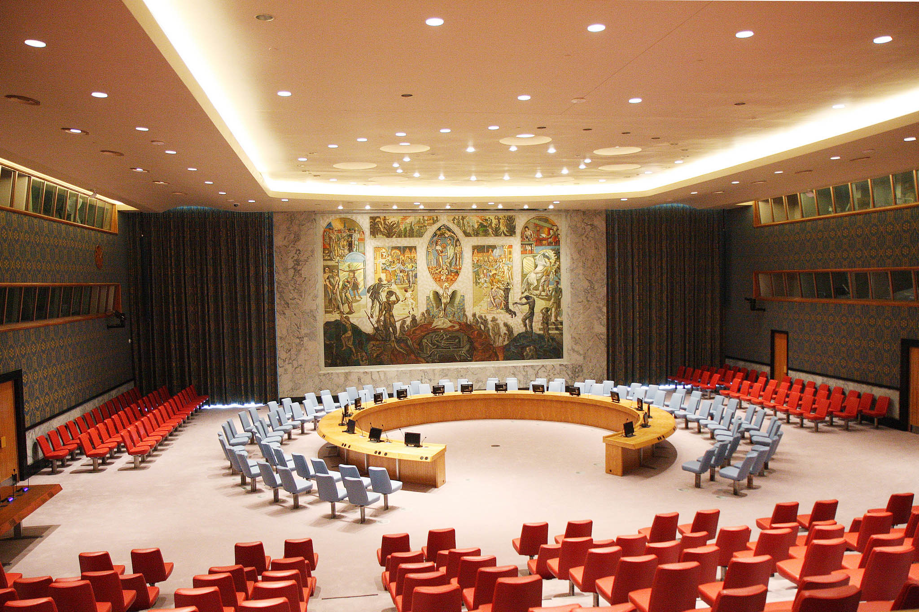
Security Council
TOPIC: Open agenda

SOCOMUN XXVII

Security Council
Open Agenda
Hello delegates! My name is Benjamin Erhardt. I am a senior at Santa Margarita, and will be your committee chair for SOCOMUN XXVII. Alongside my Legal, Roya Khoja, and my Secretary, Patrick McGowan, I look forward to making SOCOMUN a great experience for all of you. A little bit about myself: I have been in the MUN program at Santa Margarita since my freshman year, I play on the Varsity Golf team, and I participate in many other extracurricular activities on campus, such as clubs and ASB. By participating in the MUN program at Santa Margarita, I’ve been able to develop many skills that I now use in my daily life, which include public speaking, creative thinking, essay composition, face-to-face interaction, and debate skills. I have had the great opportunity to travel to an international conference in Philadelphia, Pennsylvania (the Ivy League Model United Nations Conference or ILMUNC) where I used my skills to interact with other MUNers from around the world. Security Council is my favorite committee to be a part of, so I look forward to chairing in it for the first time!
I hope that you all enjoy your experience at SOCOMUN! It’s a great opportunity to not only hone your abilities if you are a more advanced MUNer, but it is also a great place to try MUN if this is your first conference. You will effectively present your country’s policy and solutions to a specific problem for the entire committee to informally debate and discuss during caucuses. You will then create resolutions in your caucus group and present them to the whole committee to vote on. Now, because our topic is open agenda, a delegate may present any possible topic for debate at the beginning of committee. However, for the sake of making debate fair for all delegates, this topic synopsis will be devoted to the Syrian Civil War. I strongly recommend that you prepare to debate this topic in committee, and that this topic is passed as the topic of the debate the day of the conference. However, you are more than welcome to prepare for any other topic you wish to debate as well. Just be aware that the chances of us debating the Syrian Civil War are much greater than any other topic at this point in time.
If you have any questions at all regarding SOCOMUN or MUN in general, do not hesitate to email me at this committee’s email address (socomunsc@gmail.com). I look forward to seeing all of you in committee!
Background:
The background of a topic is always the greatest asset of a delegate. Knowing a topic well can be the difference between performing well in a conference or not. This is especially true at SOCOMUN. Background knowledge can help you form effective solutions and give you an idea of what your country’s position is in a certain topic. Personally, I have found that the most knowledgeable delegates can take the lead in almost any discussion in committee, so research is key:
The Syrian Civil War is an ongoing conflict that began in March 2011 after demonstrators were killed by security forces. Within months, violence exploded throughout the nation among rebels and the pro-government forces of Bashar al-Assad, Syria’s leader since the civil war began. International organizations, such as the Arab League immediately condemned that actions of the Syrian government in response to the uprisings. For the first year, factions against Assad’s forces fought separately, but then unite in November 2012. While the fighting continues, the terrorist group the Islamic State of Iraq and Syria (ISIS) arose in the region, creating a new fold in the civil war. The international community banded together to take down ISIS, and, as of October 2017, ISIS had reportedly lost much of its control in Syria, including its self-named capital city of Raqqa. However, the war between Assad’s forces and rebels has not been successfully concluded. In fact, in recent years, the Syrian Civil War has expanded into more of a proxy war, with Russian forces supporting Assad’s regime, and American special forces working with rebels and Kurdish forces who fight against Assad in Northern Syria. The United States has also conducted military strikes against pro-government forces in recent years. Since the war began, 500,000 Syrians have been killed, included thousands of children.
Within the Syrian Civil War, there are two important aspects of the conflict that make it such a critical security issue. Firstly, there have been multiple reports of the Syrian government using chemical weapons against rebels, which have in turn hurt hundreds of civilians trapped in targeted cities. Reports of chemical weapons being used have prompted UN inspections and sanctions, as well as military strikes by the United States that were previously mentioned. Sarin has been identified as the main gas used in these attacks. Secondly, the civilian crisis in Syria has grown dramatically since the war’s beginning. The United Nations High Commissioner for Refugees (UNHCR) reports that over 5.6 million Syrians have fled the country, and that another 6.1 million are displaced within the war-torn nation. While many attempts have been made to rescue trapped civilians in war zones by allowing them to evacuate, aid efforts have often become marred by ongoing violence. The UN has even had to pull aid workers out of Syria in September 2016 after an aid convoy of the Syrian Arab Red Crescent was attacked.
The UN has been very involved in this conflict since its beginning. It has conducted several inspections of Syrian chemical plants in response to rumors of chemical weapons being used during the war, facilitated ceasefires and peace talks that have failed to be successful in ending the conflict, and has sent aid to the region to help civilians fleeing the violence. Most recently, it passed resolution 2401 which entailed a 30-day ceasefire that failed to be properly enforced. Other resolutions, such as resolution 2139 and resolution 2268 called for humanitarian workers to be permitted access to rebel-held areas where civilian aid was desperately needed.
Possible Solutions:
To help guide you research, I would like to give you a few possible solutions to this topic. While these may be used to build more detailed and effective solutions in committee, I would recommend that you try to come up with your own solutions to present in caucus. Always remember to keep your country policy in mind when developing solutions. Make sure your solutions are detailed and well-developed. If you have more comprehensive solutions constructed in committee, then your resolution is more likely to pass in voting bloc. Do not be afraid to think outside of the box to create uniquely effective solutions:
Peace Talks and Ceasefires:
Of course, the most diplomatic way to resolve this conflict is to encourage peace talks between leaders of both the conflicting groups involved and the proxy nations involved in this war. Maybe entertaining a summit or a conference between these leaders would be a practical way to begin peace talks. These talks should focus on how to limit Assad’s power, and how to dismantle Syria’s illegal chemical weapons program. Keep in mind that this should be more of a long-term solution, as two conflicting sides don’t often instantly compromise after meeting once. A short-term solution regarding this could be implementing temporary ceasefires while peace talks are ongoing. The biggest road block to maneuver around with this solution is the past failures of enforcement.
Military Action:
If peace talks fail, the United Nations may need to move more armed peacekeepers into Syria to protect fleeing civilians and deter armed fighters from attacking humanitarian workers. This solution may become more realistic if Syria continues to use chemical weapons against civilians, leading to international retaliation. The UN could also coordinate airstrikes against chemical weapons sites, such as those that have been conducted by previous international coalitions. This could deter future chemical strikes.
Embargo on Arms:
The main flow of support to rebels and the Assad regime comes from nations such as Russia and the United States. If moratoriums on weapons transported to Syria are not properly followed, then it may become necessary to place economic sanctions and enforce embargos of arms from these proxy nations. This can help limit the number of arms being used in the war, thus expediting the conclusion of the war. It would also be wise to establish some form of a database to track chemical weapons and other arms that are moving throughout the region.
Humanitarian Aid
Russian soldiers have attempted to permit humanitarian corridors to be opened for fleeing civilians, but these have failed in the past due to a lack of effective security along proposed routes. By sending in peacekeepers to strictly protect civilians utilizing the corridor to flee, then these corridors might become more effective. It is also important for leaders to meet to discuss the civilian crisis. Likewise, immigration officials may need to become involved, due to the massive influx of refugees in Mediterranean nations from Syria. These talks could occur in conjunction with future peace talk summits, and should include the UN Envoy to Syria.
**Funding for Solutions**
Please note that solutions that may require extensive funding will be funded by the United Nations unless you choose to otherwise specify where funding may come from (i.e. donations from other international bodies).
Questions to Consider:
To also help guide your research, the following are some questions that you should consider when developing solutions to the topic. To me, this is the most effective tool that you can use when preparing for an MUN conference. You do NOT have to answer only these specific questions in committee. They are here for you to use as a starting point for your research:
- What is the position of your country in this conflict? What actions has your country taken in the past that relate to this conflict?
- What is your country’s stance on the usage of chemical weapons to wage war?
- Numerous ceasefires have been implemented in the past, but they have often failed due to lack of enforcement. What actions can be taken to ensure that future ceasefires are enforced more effectively?
- Should there be a limit on the amount of outside aid given to militants fighting this conflict from larger superpowers (i.e. Russian Federation and the United States)?
- How can UN workers providing aid to injured civilians and journalists covering the war be kept safe from the raging conflict?
- How should the UN manage the continuous flow of refugees and displaced civilians trying to escape the conflict?
- How should peace talks be organized once the conflict has been resolved?
- If the conflict were to end today, who would ultimately be responsible (Assad’s regime or Syrian rebels)? What reparations must each side pay?
- How can the Syrian government be restructured to ensure a peaceful transition from wartime-Syria to postwar-Syria?

Works Cited

Bethan McKernan Beirut. “UN Issues Blank Sheet of Paper as Statement on Syria: 'No Words
Will Do Justice to the Children Killed'.” The Independent, Independent Digital News and Media, 20 Feb. 2018, www.independent.co.uk/news/world/middle-east/syria-civil-war-east-ghouta-child-death-blank-statement-assad-air-stirkes-artillery-killed-a8219416.html.
This article discusses a recent UN action that acknowledges how violent the conflict has become. It speaks the truth about the escalating violence in Syria, especially against children and unarmed civilians. It will help delegates because it establishes a sense of humanitarian pain that all delegates must be ready to address in committee if they seek to end this civil war efficiently. It comes from a British news agency, which does contain some bias, but is effective in reporting events occurring in the Middle East.

Mousavian, Seyed Hossein. “To Solve the Syria Crisis, We Need to Overcome These Three
Obstacles.” The Huffington Post, TheHuffingtonPost.com, 7 Dec. 2017, www.huffingtonpost.com/seyed-hossein-mousavian/syria-crisis-obstacles_b_8740514.html.
This article talks about the further solutions, other than a ceasefire, that could be made, and the obstacles that need to overcome to see real improvement in the peace efforts regarding this war. The three obstacles that this article mentions are what to do with President Assad’s future in Syria, how to fight the terrorist groups in Syria, and lastly how to deal with the extremist movements and its ties to western allies. I believe that this article will help delegates, because it adds information about other pressing problems in Syria and the obstacles that government officials must surpass to see improvement. The only setback is that the Huffington Post is not always the most credible source.

Neuman, Scott. “U.N. Security Council to Try Again For Syria Cease-Fire Resolution.” NPR,
NPR, 23 Feb. 2018, www.npr.org/sections/thetwo-way/2018/02/23/588205267/u-n-security-council-to-try-again-for-syria-cease-fire-resolution.
This article speaks about the Security Council itself during voting on the ceasefire. The ceasefire itself is also mentioned, because of the advantages for Syria that it provides. The advantages include time to orchestrate a well thought out plan to further calm down and solve the problems of the civil war. The article also covers Security Council talks on repercussions that the delays and negotiations initiate, and how although they are looking for a solution, there will need to be an immediate ceasefire to calm things down and to allot time. This is a credible article from a highly-credible source: NPR.

“Syria chemical ‘attack’: What we know.” BBC News, BBC, 26 Apr. 2017, Web, 19 Apr. 2018.
http://www.bbc.com/news/world-middle-east-39500947
This source, from the BBC, is detailing the alleged gas attack on the rebel held town of Khan Sheikhoun that has left 89 people dead. Gas attacks have been outlawed by the Geneva Protocol and the chemical used was a colorless, odorless liquid called Sarin that was outlawed in 1997 by the Chemical Weapons Convention of 1993. (source for information on sarin: https://www.cfr.org/backgrounder/sarin). The two sources for this summary are both good source, although there is some bias in any BBC source. CFR is a good source because it is usually non-biased. A delegate could use these sources because they are credible and cover both sides of the story.
“Syrian Civil War Fast Facts.” CNN Library, CNN, 14 Apr. 2018, Web, 14 Apr. 2018.
https://www.cnn.com/2013/08/27/world/meast/syria-civil-war-fast-facts/index.html
This source, from CNN, contains information pertaining to everything you would want to know about the topic. It has exact dates for when everything has happened. The article is perfect for anyone who wants quick facts on the topic that could be extremely useful in committee. CNN can be biased at times, but in a case like this where it is simple raw facts there is no bias. This is the kind of article for reference during committee to fact check other delegates and their information.
“Syrian Crisis.” UNICEF USA, UNICEF, 2018, Web, 19 Apr. 2018.
https://www.unicefusa.org/mission/emergencies/child-refugees/syria-crisis
This article details the humanitarian crisis in Syria, especially regarding children. It provides statistics and paints a picture of how badly the situation has developed and how many children are impacted by the war. The article is from UNICEF USA which is generally unbiased. A delegate could use the article to formulate solutions specific to humanitarian aid.
“Syria: Events of 2016.” Human Rights Watch, Human Rights Watch, 2016, Web, 19 Apr. 2018.
https://www.hrw.org/world-report/2017/country-chapters/syria
This article from the Human Right Watch details the war crimes and atrocities committed in Syria. It focuses on 2017 human rights violations such as intentional starving. This article may have a little bias since it is focused on the civilians in Syria, and not the international leaders who have influence over the civil war. A delegate may use this article to further understand the human rights violations occurring in Syria and to form a solution addressing these problems.
“Syria: The story of the conflict.” BBC News, BBC, 11 Mar. 2016, Web, 19 Apr. 2018.
http://www.bbc.com/news/world-middle-east-26116868
This BBC source details the events of Syrian civil war since it started. It details the methods of war used in Syria, the humanitarian crisis, and everything that you would ever want to know about the war. This is a good source because BBC is usually accurate, especially on this topic, and they have been extremely detailed and concise. A delegate could use this source to gain historical knowledge and learn the background of the topic.
“The Ugly Solutions to Peace in Syria.” Harvard Political Review The Ugly Solutions to Peace
in Syria Comments, www.harvardpolitics.com/world/the-ugly-solutions-to-peace-in-syria/.
This article informs the reader about the many obstacles the government officials must pass to not only end the civil war in Syria, but also to create peace in Syria. Ending the war and creating peace are two separate problems because you can end the war, but no necessarily generate peace in the Syrian community. This article adds detailed knowledge about how Syria first divided, its current divided state, the Proxy war, and the routes for peace in Syria. This article will be helpful for the delegates because it adds more information about the development of peace in Syria which is needed to end the war. This can give delegates an idea of possible solutions.

“Syria War: UN Security Council Approves 30-Day Ceasefire.” BBC News, BBC, 25 Feb. 2018,
www.bbc.com/news/world-middle-east-43183903.
This article covers a UN-approved 30 day ceasefire. It talks about why the vote to approve the ceasefire was delayed, Russia’s thoughts on the vote, and how difficult it was to reach a consensus on the ceasefire is. This article will be helpful while writing the topic synopsis because it talks about the current situation in Syria and the reality people are living. It also gives concrete details about the civil war itself. The article itself refer to the situation as “Hell on Earth”, and also comes from BBC, making it a fairly credible source.

