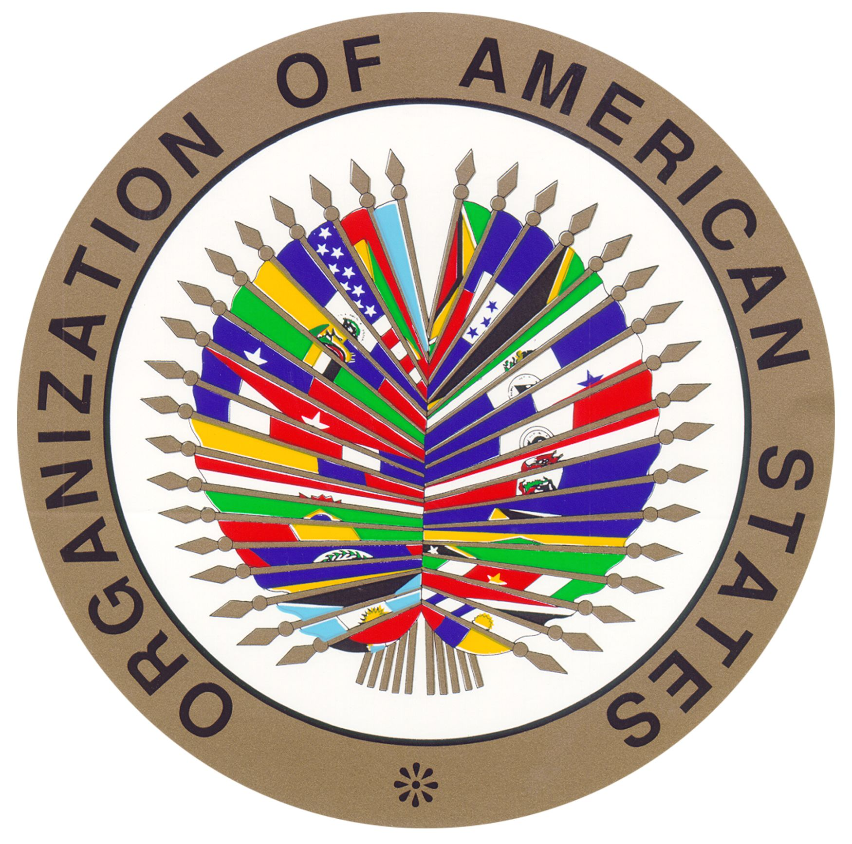
oas
TOPIC: substance abuse
SOCOMUN XXVI

Organization of American States (OAS)
Substance Abuse

Hello! My name is Audrey Narkchareon and I will be your chair for this year’s SOCOMUN! I am currently a junior at SMCHS and this will be my third year being involved in the MUN program. Throughout the years my love for MUN has grown to an unexpected extent. Coming into freshman year I strongly disliked any form of public speaking and found myself incredibly nervous in front of crowds. To my surprise MUN broke me out of my shy and nervous shell and allowed me to enjoy speaking in front of large audiences. It is because of the new experiences I have endured and the new friendships I have created that I have felt comfortable at the conferences I have attended. I really enjoy the exposure to worldly issues and the creativity used to find plausible solutions for these problems. I have found that by becoming invested in these issues it opens up a larger understanding of the world and can shape your values as a human being. Because of MUN I have found great interest in Women’s Rights, found in the UN Women committee, which drive my passion to vocalize these issues that are very prevalent in our world today. I have been so lucky to have attended the MUN conference at Yale University last January. I also look forward to attending an international conference in London in the fall. When not participating in MUN events, I am also involved in running a club devoted to helping kids in distress situations as well previous involvement in both basketball and softball teams.
I look forward to meeting you all and making your experience at SOCOMUN the best it can be. In committee, you should expect a strong debate to convey your solutions on Substance Abuse as well as make comments or question if motioned for. Background should not be the bulk of your speeches. Your speeches should be spent explaining your solutions for most of the speaking time. This is so we can focus on getting your ideas out there rather than reviewing the topics the other delegates are expected to have already researched. Discussion may continue into unmoderated caucus in which you may interact with other delegates and go into depth on your ideas to form resolutions. It is crucial to stay intact with your country’s policy as well as the topic and communicate with your peers with diplomacy. Make sure that you are respectful of each other’s ideas while in discussion and that you present your ideas with great manner. During committee, no question is a dumb question and I encourage you to feel comfortable talking to me during the breaks or to pose any concern you may have. If there are any questions on the topic or how committee will be run, feel free to reach out to me at socomunoas@gmail.com . I plan to help you all through the committee and assist you in furthering your MUN skills during this conference. I hope this conference will help guide you in your MUN career and inspire you to look into worldly issues outside of MUN. I hope you all do your best at SOCOMUN and I look forward to meeting and working with you all!

Background:

Substance abuse is the over usage of drugs or alcohol, ranging from marijuana to cocaine or other hard drugs. Unfortunately, both drugs and alcohol are becoming the reasons thousands of people are dying from overdose or the side effects each substance has on the human body. It is estimated that substance abuse costs roughly $190 billion for illicit drugs and $224 billion for alcohol. This occurs because of a decrease in productivity, the increase in healthcare costs, as well as the legal cost to continue the movement of drugs and alcohol. The most common drug being abused is marijuana. Studies have shown that these addiction rates are increasing in teens causing this issue to become prevalent in the youth. Other drugs such as cocaine, heroin, acid, methamphetamine, steroids, ecstasy, OxyContin, etc. are to blame as well. This is because approximately 16,000-18,000 overdose on these substances each year. Along with overdose, many infectious and possibly lethal diseases are being spread as well. Injections of drugs using needles or other paraphernalia are spreading HIV, AIDS, and other diseases, causing medical effects that can lead to death. Not only does this effect the users but also results in medical issues or death in the babies of addicted mothers. This is because many mothers of these children are using drugs or alcohol which not only can kill themselves but their children as well. By taking drugs or drinking alcohol, the chances of stillbirth run high. If the child does not lose its life because of the mother’s substance abuse, it is highly expected that using drugs or alcohol during pregnancy causes behavioral problems in children or for the child to be born significantly underweight. Along with these risks other side effects occur as well. Short term side effects include loss of self-control, loss of judgement, fluctuating emotions, loss of memory, paranoia, organ damage, immune deprivation and in some cases, psychosis.
Today, examples of substance abuse can be seen frequently on the news. Early in the year, 18 people have called to report an overdose in Hamilton, Ohio within two weeks. This is keeping up with the statistic stating that the United States is one of the eighth most drug addicted countries. Unfortunately, the statistics only grow from there. The two most drug addicted countries include United Kingdom in second with alcohol and Iran in first with high levels of heroin. Iran struggles greatly with opiates as well as synthetic drugs but unfortunately lacks the resources and funding to act upon this pressing issue. The reason for the high amount of substance abuse in Iran is because of the drug flow from Afghanistan. Many countries like Iran struggle with this drug flow across their borders as well. This is allowing drugs to be constantly available to the society of each country and allows substance abuse to expand more and more each day. In the United Kingdom, alcohol is a major issue in their country, reporting that 1.6 million people are alcohol dependent. Terrifyingly, only 6.4% of these people receive any help or treatment for their substance abuse. It has been recorded that 52% of men and 53% of women drink well over the suggested amount of alcohol at least once each week. This is costing the UK roughly $8.65 billion and is mostly used to support law enforcement responses. Substance abuse is increasing each year and becoming more and more dangerous with exposure to these substances occurring at younger ages. People are dying on the streets, in their homes, while driving, or face a life of hardships because of their intake of drugs or alcohol. Our actions to decrease substance abuse should be intensifying to avoid this growing death rate because of drug and alcohol abuse. Despite the implementations already taking place, substance abuse continues to be a major issue in the international community and more actions need to be put into order to save the lives of thousands of people.

Possible Solutions:

Here you will find a few viable solutions for the issue in Substance Abuse. After reading these solutions you are highly encouraged to formulate your own ideas as well as create other solutions in collaboration with your respected delegates during the conference. I recommend coming with these solutions prepared, when comes time for the actual conference, to ensure your best performance. It is important that your solutions stay true to your country’s policy and that they are presented in detail to avoid confusion. Your solutions do not have to be concerning the funding of your ideas. It is anticipated that all funding would be decided upon by the UN in the Fifth Committee and World Bank.
To combat substance abuse, it may seem important to certain countries to decrease the drug trade across borders because this is fueling the use of drugs. This could be done by increasing border patrol and amplifying security searches before a person is allowed into the country. Smuggling drugs is a big problem for many countries which is why this is possible. In respect of countries that rely on drug trade as a part of their economy, such as in Colombia, it is important to discuss with other delegates on how an agreement may be formed. If a problem like this arises, perhaps support multilateral or bilateral talks between these opposing countries. This will allow each country to speak with other nations on the issues they have and what they support to make amendments how substance abuse is controlled. With these talks, it is crucial to explain the specifics of what will be discussed and what your country is willing to sacrifice so that the needs of each country are met.
Nations may also want to work with other organizations such as Mentor. This nonprofit works towards preventing drug abuse by focusing on the youth. By providing support and implementing evidence based programs, Mentor looks to empower young people by developing their decision making and help grow their self-esteem. You must work to make these organizations available internationally and make clear if any alterations will be made based on the characteristics of each country. Remember that funding is not of our concern but delegates may bring this up. It is important to remind each other of this in order to discuss other topics that may be more important. Keep in mind that people may oppose ideas based on their country’s view on this topic as well as object because there is an overruling of their sovereignty. Work with those who support your ideas on substance abuse but also make sure to hear the opposing opinions. Contradictions will occur but this is expected because of different country policies. Not everyone will agree with your ideas but it how you present your solutions that truly matters. We are working to help the international community and this should be your main goal.

Questions to consider:

These questions are used to help guide you in your research of this topic. You are not expected to have these questions answered for the conference and are a completely optional resource to help your research. These questions will help you understand your country’s policy better as well as help draw your attention to the pressing issues in this topic:

- What is your country’s policy? What actions has your country taken against substance abuse if any?
- What organizations have become involved in this issue? Internationally or locally? What makes these organizations better than others?
- Does your country support other countries in their response to this issue? Who are your country’s allies? Who does not support your country?
- What actions have the United Nations taken on substance abuse? What resolutions did they form? Are these proposed resolutions being implemented? How?
- Why are some types of drugs available in more places than others? How does drug trade work? How can these people be stopped from transporting these drugs?
- What are the problems occurring in your country on this topic? Do other countries have the same issues? What do you see is a common trend with drugs and alcohol?
- Will the new legalization of marijuana in some countries affect this issue? How is this issue expected to change throughout the years?
- How might places like Colombia be supported if the drug trade or substance abuse declines because of actions against it? Is your country willing to support those experiencing this possible change?
- What help do you see fit for those affected by substance abuse? Are those who use the drugs or alcohol the only ones affected? What programs have helped people involved in the past? How will they work now?
- Do old implementations need to be reformed? Has substance abuse in the modern world changed since last addressed?
- Will others present solutions for specific types of drugs? What drugs do you think are most important to bring up?
- Is the alcohol age too low? What information may delegates use to argue this point?

Works Cited
Bribota. "Top 8 Most Drug-Addicted Countries." Blvd Treatment Centers. BLVD, 04 Jan. 2017. Web. 08 Apr. 2017. <https://www.blvdcenters.org/blog/top-8-drug-addicted-countries>.
This source is very useful because it talks about the top 8 countries that are affected the most by drug abuse and face drug addiction through their civilians. Countries such as Iran, United Kingdom, France, and others were named. The drugs that were mentioned in this article ranged from drugs that are easily accessed such as prescription pills to hardcore drugs like heroine. There are also statistics that were recorded by the United Nations Office on Drugs and Crime which point out the impact of drugs in each nation and have recognized the harm of illicit drugs. The UN Office of Drugs and Crime also talks about their hopes for creating a brighter future without drugs with the help of many other UN organizations. This informational will be valuable for Background when talking what countries are impacted, UN Involvement when mention the United Nations Office of Drugs and Crime, and in Country Policy depending on what bloc your country is from.
"Get the Facts on Substance Abuse." DrugAbuse.com. DrugAbuse.com, 28 Jan. 2016. Web. 21 Apr. 2017. <http://drugabuse.com/library/get-the-facts-on-substance-abuse/>.
This website contains information of substance abuse. It defines substance abuse as well as provides statistic on the effects of Substance abuse. It goes into detail on prescription drug abuse and on the short term and long term effects of substance abuse. It also provides a video explaining substance abuse to a greater extent. This website is useful because of the facts and statistics it provides. It also is run by an organization helping those involved in substance abuse. It is guiding people to help their addiction in ways other reliable sources have before. This source offered significant help in the statistics of my writing as well as introduced additional information that I had not found yet.
"The Organization of American States Inter-American Drug Abuse Control Commission Group of Experts to Control Money Laundering." U.S. Department of State. U.S. Department of State, n.d. Web. 07 Apr. 2017. <https://www.state.gov/j/inl/rls/nrcrpt/2016/vol2/253362.htm>.
This source goes over the different organizations that have been established within the OAS in order to diminish the issue of drug abuse. It talks about the CICAD creating programs and workshops in order to spread awareness of the AML/CFT issue within Central and South America and the Caribbean and improving their standard. The CICAD has taken involvements within specific nations that are most affected by substance abuse. Also this article mentions the report of the International Narcotics Control Strategy Report (INCSR) and its law enforcement affairs as well as its involvement with other organizations such as the BIDAL. This information will be useful in UN Involvement because it talks about multiple UN organizations taking action with drug abuse and also you can use the information in Country Policy/Involvement depending on which country your bloc is from, you can say how the organization works with your nation.
"Mentor International." Mentor. N.p., n.d. Web. 06 Apr. 2017. <http://mentorinternational.org/about-mentor/about-us/>.
This website gives an organization that could be used in a possible solution for the topic of substance abuse. The organization called Mentor International “makes prevention effective and visible by targeting young people and those around them”. I would consider this source pretty reliable due to the fact that it is organized with contact information with its members. Also, the website provides a portfolio of the organizations past involvements and successes.
NIDA. "About NIDA." NIDA. N.p., n.d. Web. 05 Apr. 2017. <https://www.drugabuse.gov/about-nida>.
This website provides useful information on the National Institute of Drug Abuse. This website could provide a lot of valuable information about drug abuse and how to possibly prevent it. With the information given in this website, I think that understanding the topic and brainstorming workable solutions will become much easier. This website also shows tons of research conducted by NIDA In hopes of how to prevent substance abuse disorders. I would view this website as an extremely reliable source for numerous reasons. Firstly, .gov websites are known to have extremely reliable sources. Along with this, the website is run by an international organization.
"OAS - Organization of American States: Democracy for Peace, Security, and Development." OAS - Organization of American States: Democracy for Peace, Security, and Development. OAS, 01 Aug. 2009. Web. 07 Apr. 2017. <http://www.oas.org/en/topics/drugs.asp>.
This website talks about the abuse of drugs and where it is most prevalent, as well as its effects on society. It also mentions the involvement of the OAS within the issue of substance abuse and what actions they have taken towards combating this issue, such as their projects directed towards supply, demand reduction, and developing stronger anti-drug institutions within each state. I would use this information in Background because you can mention this organizations sole purpose as well as what substance abuse is and you can use the hyperlinks for more information. Also, the information can be used in UN Involvement and Past Actions, because it discusses what projects and organizations have been set up in regards to combatting the issue of substance abuse and how some countries have been involved as well.
Secretariat, CICAD Executive. "About CICAD." Inter-American Drug Abuse Control Commission (CICAD). OAS, n.d. Web. 07 Apr. 2017. <http://www.cicad.oas.org/main/default_eng.asp>.
This site is very useful as it talks about the Inter-American Drug Abuse Control Commission (CICAD) and their action taken when it comes to substance abuse. It mentions the past sessions and meetings the CICAD has called to discuss the dilemma of substance abuse and have put their focus on controlling the drug abuse. This website lists all of their past and upcoming sessions that have been called to order, and through this site you are able to find information on the sessions like where it will take place, the date it is on, and in some cases there are online registrations. They’re most recent session is coming up and it is from April 24 through the 27. This information will be useful for UN Involvement as the CICAD is under the OAS, and all their past and current actions are mentions and elaborated on.
"Substance Abuse Problems: MedlinePlus." MedlinePlus Trusted Health Information for You. N.p., n.d. Web. 07 Apr. 2017. <https://medlineplus.gov/substanceabuseproblems.html>.
I would view this source as very reliable due to the fact that it is run by the United States National Library of Medicine. Along with this, the website is very well organized and not thrown together like other unreliable sources. This website is very helpful because it lists all of the different types of substance abuses that are seen in the United States and around the globe. By just clicking on one of the countess sub categories, such as drug or alcohol abuse, and it will automatically bring you to a summary of the specific substance abuse you chose. Overall, I think this is a great source to get a good footing and understanding of the possible sub categories within the topic of substance abuse.
Tragen, I. G. "Co-operation of Countries." Bulletin on Narcotics. U.S. National Library of Medicine, n.d. Web. 08 Apr. 2017. <https://www.ncbi.nlm.nih.gov/pubmed/2441787>.
This is a resourceful site because it discusses the cooperation of countries within the Organization of American States in hopes of combating the drug problems. First it talks about the OAS itself and how it is an intergovernmental organization of a number of member States, and how it has given priority to states in most need of fighting the struggle of substance abuse. It goes more in depth in facts about the OAS and its different works to stop the drug abuse and to prevent drug trafficking. It mentions the establishment of the Inter-American Specialized Conference on Traffic in Narcotic Drugs which first took place in 1986 in Rio de Janeiro, but it continues to have meetings. This Conference reduces the amount of illegal substances being transported from nations. This information can be used in Background, UN Involvement, and Country Policy because it discusses basic facts about OAS and substance abuse, the OAS actions that have been taken in regard to substance abuse, and it discusses he involvement of some countries and how they are affected.
UNODC. International Standards on Drug Use Prevention: n. pag. UNODC, Feb. 2015. Web. 7 Apr.2017.
<https://www.unodc.org/documents/prevention/UNODC_2013_2015_international_standards_on_drug_use_prevention_E.pdf>.
This PDF provides a document written by the UNODC. With this information alone, this source can be viewed as very reliable. This PDF provides the reader with the international standards for drug use prevention. With these standards being understood, the topic and the conflicts within it can be more comprehendible. This source will be helpful for not only understanding the background of the issue, but also in brainstorming possible solutions.
Wilcox, Stephen. "Facts about Drugs." National Council on Alcoholism and Drug Dependence. NCADD, 26 Apr. 2015. Web. 21 Apr. 2017. <https://www.ncadd.org/about-addiction/faq/facts-about-drugs>.
This source mentions the costs of drug abuse, the most used drugs, and the short term and long term effects the drugs have. This website was very helpful because it gave statistics and facts about drug abuse that were very useful in my paper. The goal of this website was to inform the readers about drug abuse which was conveyed in a very intelligent way. I was able to use to this for facts and basic information which helped form my paper.

