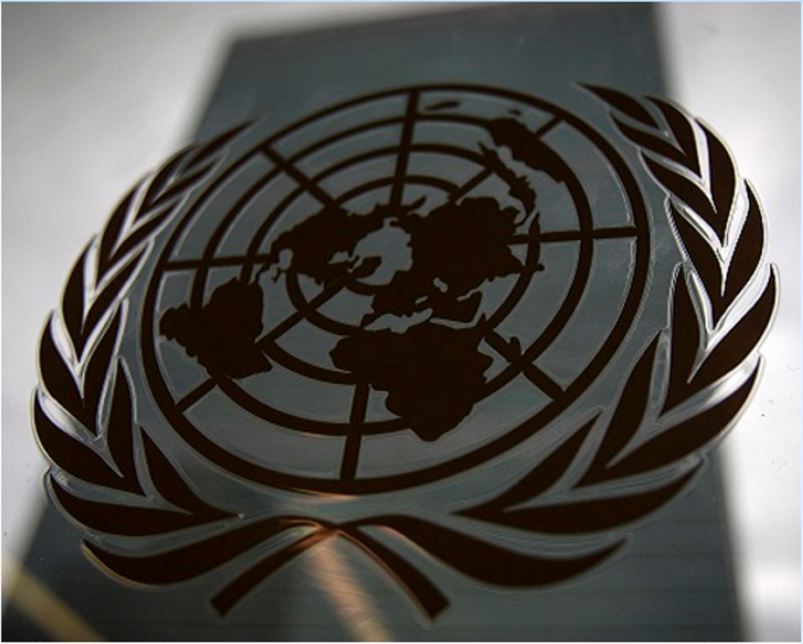
NOT FRESHMAN B
NOT FRESHMAN B
TOPIC: SMALL ARMS PROLIFERATION

SOCOMUN XXVIII
Small Arms Proliferation

Introduction:
Hello Delegates! My name is Alex Qubain and I have the privilege of being your head committee chair for SOCOMUN this year. I am currently a Junior here at Santa Margarita and I started in Model UN as a freshman. The past 2 years have not only helped me grow personally but also as a speaker and scholar. All this was possible through the demanding academic research and competitive public speaking requirements provided through the MUN program. Through the program, I have been fortunate to attend several valuable conferences, including one at UC Berkeley this past March as a sophomore and I will be attending one in London this coming year! Outside of MUN, I enjoy travelling to visit family, playing music and practicing martial arts. The MUN program has allowed me a much deeper insight into various significant world matters and I have also begun to understand the depth of complexity of the many issues facing our global community, and the means needed to effectively deal with these issues and mitigate their impact. It is my sincere desire that this conference offers you all the same pathway to knowledge and understanding.
SOCOMUN provides a unique opportunity for you delegates to begin to grasp the fundamental concepts involved with Model UN including public speaking, extensive academic research, presentation skills, compromise through negotiation and exchange of differing opinions. Our committee’s goal for this conference focuses specifically on the topic of Small Arms proliferation as specified through the United Nations Office on Drugs and Crime. In order for you to be successful in this conference, I urge you to research and understand the specified position of the United Nations Office on Drugs and Crime (UNODC) related to the main points of this issue, which you can find through the extensive information on their official online resource. As a committee, we will be debating these topics through different means- both formal and informal conversation, known as caucusing, which you as a delegate can motion for, as well as through opportunities for delegates to present their solutions/positions on the topic through individual speeches. It is important to remember that you are representing an assigned country and a key success factor is understanding your country’s policy on this particular issue and representing it accurately.
Model UN has greatly increased my awareness of the vast and intrinsic cultures, values and issues facing many nations in the world and has increased my abilities to realistically, impartially and efficiently dissect an issue and analyze its ramifications. I hope that your experience with this conference will lead you to pursue many more conferences and that you continue with MUN! Lastly, I want to welcome you all to SOCOMUN, and if you have any questions at all over the course of you research and preparation, please feel free to email me at socomunnotb@gmail.com
Hello delegates, I am Mary Kate Tracy and I will be your vice chair for this SOCOMUN conference. I am currently a junior here at Santa Margarita Catholic High School. I got involved in MUN as a freshman because I wanted to experience the challenge of MUN. The class and competition has taught me many valuable lessons from strong public speaking to efficiently researching a topic. Aside from school and the rest of my studies, I participate in club swim and am on varsity swimming here at Santa Margarita. I also enjoy playing the piano and guitar. I am looking forward to having a great conference with all of you, have fun researching!
Hello, my name is Jackson Kopeny. I will be your rapporteur for this SOCOMUN conference, basically meaning I’ll be recording and helping to monitor committee. I am currently a sophomore, and this is my second year in MUN, and I plan to do it throughout high school. I am excited to experience MUN in this type of position and look forward to meeting all of you in committee!
E4JMUN Resources from the UNODC

The UNODC has provided some great resources for students involved with Model United Nations.
https://www.unodc.org/e4j/mun/crime-prevention/firearms.html- Information about firearms. Also information about firearms and the sustainable development goals.

https://www.unodc.org/e4j/mun/resources/firearms.html- Looks like the other link but scroll down and you will see some links to additional resources. There is a lot of useful information here. Take some time to look through these documents.

Background:
Small arms and light weapons refer to individual, man-portable lethal weapons ranging from handguns to rifles and sub-machine guns as well as collectively operated weapons that can be transported by light vehicles including such weapons as grenade launchers and recoilless rifles. Small arms and light weapons are characterized by their ease of use, specifically in transfer, and the lack of logistical and maintenance support needed to operate them. In recent years, the manufacturing for these weapons has increased exponentially, due to the increased market demand both legally and illicitly. The practicality of these types of weapons, paired with the increase in manufacturing and demand, creates a dangerous market that can and has been negatively exploited. An independent research study at the Graduate Institute of International Studies in Geneva, Switzerland, concluded that, as of 2006, out of the $4 billion dollars of annual global markets related to small arms, 25% of those $4 billion went towards illicit markets and illegal weapons. The discrepancy between legal and illegal markets of small arms, specifically how and by who transactions are carried out, creates an unstable and increasingly dangerous weapons market that causes disruption to trade, investment and general economic development as well as jeopardizes regional tranquility and autonomy.
Today, small arms and light weapons are responsible for more deaths than any other conventional weapons associated with warfare such as a tanks, aircrafts or warships. Two things contribute to this problem, the ease of availability and the practicality of use. Both legal and illicit markets are readily available for the purchase of small arms, with this availability only increasing the occurrences of armed conflict and the intensity of these occurrences. The increased proliferation of small arms has also led to a plethora of human rights violations common today, as much of the armed conflict involving these weapons includes children and teenagers and increases the likelihood of higher rates of collateral damage and civilian death. Globally, almost 50% of all violent deaths occur as a result of the use of small arms, and small arms are responsible for 60-90% of deaths related to direct conflict.
As the growth of the small arms market has increased exponentially, so has arisen the problem of arms monitoring and the control of these arms markets. The monitoring of these markets has not been very successful, due to the lack of organized monitoring and oversight methods. Whether through illicit markets, legally, or through “covert” and “gray-market sources”, meaning sources that violate official government policies but operate through illicit governmental support, unorganized control of markets has made it increasingly difficult to monitor the use of small arms, with much of the problem arising from the original acquisition of the arms themselves. Many weapons involved in violent conflict or illegal activity were once registered and legally purchased weapons, as seen represented by a study done through the government of the Brazilian state of Rio de Janeiro which stated that 72% of the guns used or related to crimes had once been legally registered. The variation in methods of acquisition within the arms market and the lack of oversight regarding the trade and acquisition of small arms allows for increased levels of arms trafficking and increased criminal, violent and general illegal uses of trafficked arms.
The United Nations has released several resolutions and statistical papers relating to the proliferation of small arms, including the 2006 International Instrument to Enable States to Identify and Trace, in a Timely and Reliable Manner, Illicit Small Arms and Light Weapons, which specifies the need for increased control and monitoring of small arms markets by countries through an enabled international body or instrument. Additionally, the United Nations has focused extensively on the illicit proliferation of small arms and the monitoring and control of illicit small arms markets, as the trafficking of firearms was completely recognized by the United Nations Firearm Protocol and the United Nations Program of Action on Small Arms in 2001. The protocol explicitly defines trafficking as “the import, export, acquisition, sale, delivery, movement or transfer of firearms, their parts and components, and ammunition from or across the territory of one State to that of another State if any one of the States concerned does not authorize it in accordance with the terms of Protocol or if the firearms are not marked in accordance with article 8 of this Protocol.” in article 3(e) and calls for the combat of trafficking in firearms as a major goal of the international community. The UN General Assembly also understood the need to recognize the issue of Arms proliferation relating to violence and insecurity, and specifically, through the establishment of the 17 sustainable development goals in 2015, created goal 16, Peace, Justice and Strong Institutions which refers to small arms proliferation through armed violence and security, corruption and firearm flows, and other related topics with the main goal of significantly reducing illicit arms flow.
Possible Solutions:
Based upon the information presented in the previous background, below are some solutions or plans of action you as a delegate might want to consider in developing your own solutions that you will have the opportunity to present during committee. As the representative of your country, you should present solutions and viewpoints that align with your country policy that you believe will be beneficial in solving the problem, or that your country strongly believes regarding the issue. Through the background, it was explained how one of the focal points of this problem should be the manufacturing and manner of distribution of firearms, whether illicit or legal; so, a possible solution for the lack of control and monitoring of small arms markets might be some sort of requisite for manufacturers to implement Radio frequency Identification (RFID) or using telemetry to monitor the unique identification numbers (SKUs) for each unit manufactured thus allowing automatic remote and easy tracking, recording and monitoring of sales and movement of such devices. Additionally, the establishment of an international database and IT systems framework for cross-functional monitoring across various enforcement agencies and borders of shipments made via air, land or sea across country borders might be a viable part of a solution for increased arms monitoring. Another fundamental point that you as a delegate might want to address is the illegal stockpile of small arms and how to mitigate illegal stockpiles through working to create and enforce international guidelines such as UN conventions or international mandates requiring the destruction of illegally seized shipments of arms as well as arms and ammunition that have been used in old wars for sale to illegal entities and guerrilla forces (i.e. Kalashnikovs used during the cold war which have been sold and used by Sudanese and Afghan rebels illegally). Additional enforcement of international peace standards might be able to be done through the creation of treaties between countries to prohibit the movement of old arms and ammunition as well as sale of any arms and ammunition to illegal entities or shell companies in suspect parts of the world. In tandem with this, it might be effective to consider media platforms and the publishing and sharing of intelligence across international agencies to minimize and eventually eliminate the sale of such arms to illegal entities and use. Once again, as I expressed earlier in the introduction, the direction of our committee’s debate should expand upon the problem as described by the United Nations Office of Drugs and Crime, so I would strongly recommend you explore the UNODC’s position on the issue to see what issues it focuses on regarding this topic, as that might affect the way you develop you solutions. Lastly, it is also important to note that we as a committee do not have to worry about the organization or planning of funding matters needed for proposed solutions, because organizing funding of passed solutions is the explicit purpose of the 5th Legal committee and any solutions approved by committee would be funded by the UN.
Questions to consider:
Below are some questions for your consideration when researching and preparing solutions and country policy. These questions are not required as part of your responsibility during the conference and you will not be graded on addressing these questions. These are simply here to guide you in more extensive research and understanding of the topic.
- What are the gun laws in your country, both regarding purchase/ownership as well as regarding domestic regulations on trade and manufacturing? And how does this influence the main points of your solutions?
- What international regulatory or monitoring conditions/mandates are currently set in place and how effective are they?
- What other social, political or economic issues relate to this problem? Maybe the import and export balance of a country or the political relationships within regions affect how arms are transferred and manufactured?
- What other crimes and illegal activity are facilitated by the increasing presence of small arms and light weapons? And how do these crimes vary by region?
- How does the proliferation of small arms affect regions differently based on the financial or economic prosperity of the region? In other words, what is the difference in effect of small arms in developed areas versus more developing areas?
- How is a small arm or a light weapon officially defined on an international level and does the way these things are defined affect anything? What should officially be considered a small arm or light weapon, and what shouldn’t? Does defining these things matter?
- What underlying issues could be addressed that would mitigate the effects of this problem? Different sociocultural or economic problems can directly correlate to the problem of illicit use of small arms. Would addressing these different issues be effective in solving this problem? (example: A child recruited into guerilla warfare using small arms is almost always dragged into this due to a lack of family structure or no educational/economic opportunity.)

Works Cited:
“Arms Control Today.” Small Arms and Light Weapons: Controlling the Real Instruments of War, www.armscontrol.org/print/391.

This website discusses the use of illicit and black-market channels to transfer light weapons. It also discussed the appeal of small firearms toward many people such as the fact that they are low cost and widely available. This website focuses partially on the people who buy the weapons and the reasons why they buy them, providing a good basis for some solutions. It also provided some possible solutions such as an increase in state accountability. Overall, this website made me realize the complexity of this issue and how there are many reasons and ways people can get these weapons.

“Background.” Small Arms Survey, 5 Feb. 2017, www.smallarmssurvey.org/salw/about/background.html.

This website provides a thorough background of the use of firearms and the casualties that they cause. It also discussed up to date information about the Sustainable Development that will be in the 2030 Agenda. Although this website has a lot of good information, it is short and doesn’t go into a whole lot of detail. This website would be a little bit clearer if it included more information about the topics it introduces. Overall, I learned that 44% of deaths are a result of firearms which means that almost half of the people who die had their lives taken away from the. This statistic really opened my eyes to the immensity of the issue.

The Global Threat of Small Arms and Light Weapons --A Primer, fas.org/asmp/campaigns/smallarms/primer.html.

This article provides a summary of all of the different people that are impacted by the spread of firearms. These people include civilians who are caught in the crossfire of warfare, children who are often recruited to become soldiers, and many other innocent people. It also provides information about where the weapons currently come from. This cite is useful in finding statistics of people who are most effected by the spread of fire arms, and therefore who the solutions must focus around. This cite also provides a lot of information of the origin of firearms which provides a good starting place to begin proliferation. Reading this article helped me to grasp how many people are truly affected by the use of firearms and increased my awareness in the need for proliferation.

The Global Threat of Small Arms and Light Weapons -- A Primer, fas.org/asmp/campaigns/smallarms/primer.html.

This website expresses the truly catastrophic effects of small arms, as they are the cause of 90% of civilian casualties and about 300,000 to half a million people around the world are killed each year. This page also includes quotes from different arms treaties and activists. This article does an especially good job of expressing the different views on firearms and ultimately the need for change as many people are dying. This website helped me understand the pure numbers of how many people’s lives are stripped away because of firearm proliferation.

“The UN Role and Efforts in Combating the Proliferation of Small Arms and Light Weapons | UN Chronicle.” United Nations, United Nations, unchronicle.un.org/article/un-role-and-efforts-combating-proliferation-small-arms-and-light-weapons.

This article outlines all the previous efforts taken by the United Nations in combatting the proliferation of firearms. It specifically includes UN programs such as the United Nations Programme of Action to Prevent, Combat and eradicate the Illicit Trade in Small Arms and Light Weapons in All its Aspects. Overall, this website expresses the magnitude of efforts that the United Nations has already put in toward solving this issue in great detail. Although the website is very detailed, it only provides information through 2012 and does not include information in the most recent years. Ultimately, this website demonstrated how much effort has been put in toward solving the proliferation of firearms, yet no sustainable solution has been reached.

Katharina.kiener-Manu. “MUN Firearms.” MUN Firearms, www.unodc.org/e4j/mun/crime-prevention/firearms.html.
This source summarizes previous actions that the UN has taken to prevent incorrect use of firearms specifically as expressed through the UNODC. This also explains the use of many NGOs to help with this problem. The source focuses extensively on the relation of this problem to the Sustainable Development Goals, which could be helpful in relating the involvement of the United Nations with the topic thus far to how certain resolutions or mandates have affected the issue.

“UN Documents for Small Arms.” Security Council Report, www.securitycouncilreport.org/un-documents/small-arms/.
This source explains all the previous Security Council resolutions passed at previous councils. It explains how they went into effect and how they affected this issue. This source provides details purely on the resolutions already passed by previous Security Councils and relates to specific times of crisis that were caused by an issue related to this topic. This source provides extensive information regarding the direct effects of previous Security Council resolutions and how these were put into effect.

“Arms Control Today.” Small Arms, Large Problem: The International Threat of Small Arms Proliferation and Misuse | Arms Control Association, www.armscontrol.org/act/2006_06/SmallArmsFeature.
This source focuses on the general issues related to the use of firearms and how dangerous they can be if used in aggressive manners. It also expands upon background information explaining how the misuse of firearms is becoming an increasing threat to civilian life. The source basically expresses the importance of regulation regarding firearms and the importance of international cooperation. Additionally, the source elaborates on general factors relating to the issue including trade regulation and monitoring.

“Small Arms-They Cause 90% of Civilian Casualties.” - Global Issues, www.globalissues.org/article/78/small-arms-they-cause-90-of-civilian-casualties.
This source focuses on the civilian ramifications of using small arms. It also focuses extensively on the definition of a small arm and how or what is defined as a small arm or light weapon. The source clarifies the extent to which small arms use affects every day life of civilians globally and how the unregulated and proliferated use of them has increased death tolls substantially.

Nato. “Small Arms and Light Weapons (SALW) and Mine Action (MA).” NATO, www.nato.int/cps/en/natohq/topics_52142.htm.
This source extensively explains how different factors relating to small arms lead to misuse of small firearms like pistols, land mines, and even light missiles and how this creates an endangerment to regional security. The source elaborates on the socioeconomic ramifications of the proliferated use of small arms and how this increased use affects different regions based on socioeconomic development.

