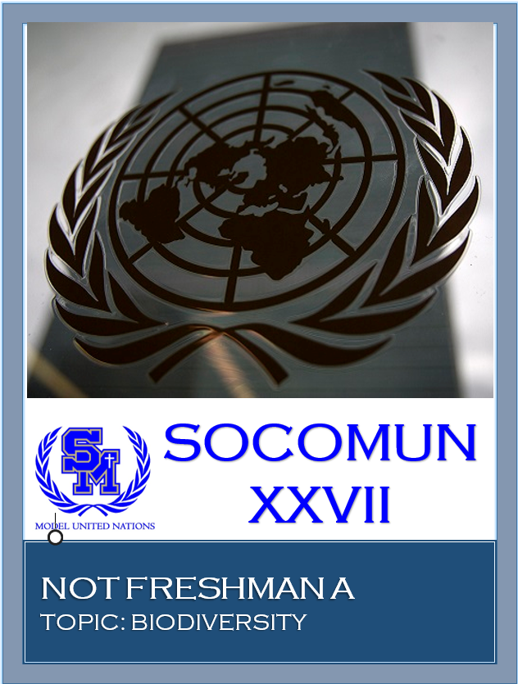

Not Freshman A
Biodiversity

Hello! My name is Ashley Kao and I will be your head chair at SOCOMUN this year! I am currently a senior at Santa Margarita Catholic High School and this will be my fourth year participating in MUN. My favorite part of MUN is the fact that we are able to work together to find solutions for dilemmas that are currently occurring worldwide. For MUN conferences, I have had the amazing opportunities to travel to UC Berkeley, UC Santa Barbara, London, England, and many more! At conferences, my favorite committees tend to be UNEP or UNICEF. Outside of MUN, I run on the track & field and cross country team, volunteer through the National Charity League and Mission Hospital, and I am an International Baccalaureate student.
My name is David Feng, and I am a junior this school year. This will be my third year participating in the MUN program at SMCHS. Other than being involved with MUN, I also play on the Varsity Tennis team. I will be your legal at SOCOMUN XXVII in September of 2018. I look forward to working with you at SOCOMUN.
My name is Sophia Christopher. I will be your secretary at SOCOMUN this year and I am a sophomore at SMCHS. Outside of MUN, I have been cheerleading for about 6 years and am now a part of the cheer team at Santa Margarita. My MUN experience started freshman year and I have won 3 awards thus far. I have grown to love and appreciate the program and appreciate the lessons and opportunities it brings.
We hope that SOCOMUN will be a great learning opportunity and look forward to meeting you at the conference. Because our committee NOT Freshman A is a novice committee and because SOCOMUN is a learning conference, do not hesitate to ask questions about procedure, policy, etc. In committee, we will begin with opening debate where delegates will give speeches about proposed solutions and country policies. We will then go into caucus, in which delegates will discuss and compose solutions together. Afterwards, you will form resolution groups and write resolution documents that will be presented at the end of committee during formal caucus. If you have any questions about research, committee, etc., please email us at socomunnota@gmail.com . Good luck delegates!

Background:
Biodiversity consists of all ecosystems and the variability of species within them. This is necessary to all species because each one upholds a role within the community. Therefore, if one species is disrupted, then all other species around them along with the environment will be heavily impacted. Thus, biodiversity is not only important for environments, but it also plays a major role in humanity. For example, biodiversity contributes to the economy of many nations. In fact, according to the conserviaationtools.org, the United States gains a total of $319 billion due to biodiversity. Internationally, biodiversity provides over $2,928 billion. This is the result of many foods and medicinal substances being harvested and produced in various ecosystems. However, because of many harmful actions made by humans, the statistics of biodiversity have decreased majorly. Because of the rapidly increasing human population, the need for natural resources have increased significantly. As a result, the amount of global warming, habitat destruction, and pollution have soared. Each of these reasons have led to the disruption of species, thus decreasing biodiversity.
Global warming consists of the release of greenhouse gases into the atmosphere and results in the deterioration of the ozone layer. Unfortunately, these greenhouse gases being released have intruded the necessary nutrients required by plants throughout different ecosystems. In addition, global warming has led to climate change, which stands as a threat to many different species. In fact, as a result of climate change, many species of lizards and frogs in tropical forests have vanished. Alongside global warming and climate change, habitat destruction has decreased amounts of biodiversity. More specifically, because of the increased need to construct more living space, human beings have displaced thousands of species, which are disturbed and forced to leave. Habitat destruction includes the process of deforestation, fragmentation, and degradation. As a result, many species have gone extinct. Pollution has also played a major role in the degradation of biodiversity seeing that 90% of wastewater is distributed through waterways in developing nations. For example, due to the many oil spills that occur, many populations of birds and marine species are at risk of decreasing or even facing extinction. Because of the high amount of toxic and industrial waste being released into the environment, thousands of species are being affected, thus decreasing the amounts of biodiversity. Moreover, because of many individual’s habits to dispose of waste through waterways, over 12% of all species are heavily affected by pollution and at risk of facing extinction.
In order to combat this issue, many nations and different organizations have taken actions to decrease the falling amounts of biodiversity. For example, the Fin Free Thailand campaign has worked to preserve shark species from becoming extinct due to fishing advocates throughout the nation of Thailand. Alongside this campaign, many non-governmental organizations such as conservation International and World Wildlife Fund have worked to protect and promote biodiversity. In addition, many nations have come together with the hope of reinforcing biodiversity. An example of this is the EU Biodiversity Action Plan in which the European Union has composed a plan focused on restoring species by recovering habitats.
In addition to these actions, the United Nations has attempted to combat this issue of decreasing biodiversity by establishing the United Nations Decade on Biodiversity from the year of 2011 to 2020. Throughout this decade, the United Nations has developed the Strategic Plan for Biodiversity in which advocates about the importance of biodiversity in addition to enforcing a framework for all United Nations members to follow. In addition, seeing that the United Nations 17 sustainable development goals encompass the issue of decreasing biodiversity, the United Nations Conference on Environment and Development was held in 1992 in order to discuss the international need for biodiversity. Within this conference, the Convention of Biological Diversity was established for the purpose of unifying UN member nations in preserving their environment along with the numerous amounts of species within them. Despite these actions taken, action still must be taken to entirely prevent the destruction of biodiversity.

Possible Solutions:
Although the following solutions may be utilized in this committee, you should compose your own solutions to be discussed in committee. Also, make sure that the solutions that you propose correspond with your country’s policy and may be implemented within your country. For example, if the majority of your nation’s ecosystem consists of tropical forests, make sure that your solutions work towards preserving species and biodiversity within that specific ecosystem. Although many nations consist of various ecosystems, solutions may differ, but cooperation between all nations is still encouraged! However, in your solutions, make sure that nothing is forced, but rather suggested to prevent from infringing on any nation’s sovereignty. Also, seeing that these solutions will potentially be passed by the United Nations, funding will not be a problem.
In order to combat the declining biodiversity, nations may each compose of reservations in order to preserve the varying species throughout their nation and to protect them from the threat of extinction. This may be done through a treaty between United Nations members in which each nation will agree to preserve 10% of the nation for the purpose of maintaining biodiversity. Within these reserves, annual scientific expeditions will be instructed in order to collect information on the different species within the nation. More specifically, through scientific expeditions, decreases or increases in species population may be tracked in addition to the extinction of a species or the growth of a new species. This information may be collected and withheld by an international database, which will be monitored by the United Nations Environmental Programme. With this international database, nations may also be able to see what actions other nations are taking to increase biodiversity. Therefore, through scientific expeditions and the establishment of reservations, the populations of species may be sustained or even increase.
In addition to the proposal of scientific expeditions and reservations, nations may suggest the expansion and continuation of the United Nations Conference on Environment and Development that occurred in 1992, or an annual conference upheld and monitored by the United Nations Environmental Programme. Within these conferences, United Nations members will gather to discuss the data collected by the scientific expeditions in order to examine the rate of biodiversity on an international scale alongside collaborating with nations’ past actions performed with a purpose of increasing biodiversity. Through this annual conference, transparency will increase, updates on technology and new ideas will be shared, and understandings about biodiversity between nations may improve, which will also increase actions taken to preserve biodiversity internationally.

Questions to Consider:
The following questions are provided for consideration and to expand your understanding and knowledge of the topic and of your country’s policy. The questions do not have to be directly answered, but are provided solely for the purpose of broadening your knowledge of the topic.

- What is your country’s policy on biodiversity? Is your country in support of biodiversity or not? If so, what actions has your country taken to increase biodiversity?
- Are there any nongovernmental organizations currently focused on increasing biodiversity? What have they done to preserve biodiversity?
- What has the United Nations done to combat the falling statistics of biodiversity? Has this been effective? If not, what other actions could the United Nations take that will be more successful?
- Considering more developing nations are unable to fund campaigns and projects to support biodiversity, what solutions will help combat biodiversity in these nations specifically?
- Seeing that many more developed, industrialized nations heavily rely on factories that release toxins into the environment thus decreasing biodiversity, what solutions do you propose could combat these environmental dilemmas, without harming a nation’s economic status?
- In addition to solutions that will increase biodiversity, what are some solutions that can be done to stop the causes of the decreasing biodiversity? (climate change, global warming, habitat destruction, pollution)

Works Cited
“5 Best Ways to Increase Biodiversity in Urban Landscapes.” Land8, 28 July 2015,
land8.com/5-best-ways-to-increase-biodiversity-in-urban-landscapes/.
This source provides a lot of great ideas in which the urban area can work to increase biodiversity. Some of the ideas are harder to realize in an urban area, it can provide us with great ideas to base from and make it more adaptable. I think the source is valid in the ideas it provides, but delegates will need to only use these ideas as a starting point.

“5) Causes of Recent Declines in Biodiversity.” Rainforest Conservation Fund, www.rainforestconservation.org/rainforest-primer/2-biodiversity/g-recent-losses-in- biodiversity/5-causes-of-recent-declines-in-biodiversity/.
This page identifies reasons to the declination of Biodiversity. It is packed with useful statistics that could be included in a research paper. The source seems reliable and the author knows what he/she is talking about. The article digs deep into the science of Biodiversity (Ecology) and clearly explains the process of the decline or increase of Biodiversity. Overall, it’s a very good source for the background research and understanding the problem.

“Biodiversity and Human Well-Being.” Green Facts - Facts on Health and the Environment,
www.greenfacts.org/.
This article is in depth and is a summary of over 20 different studies on biodiversity put together by the Millennium Ecosystem Assessment report. The information covers all aspects of biodiversity and gives an understanding of how complicated the task of preventing the loss of biodiversity is.

“Biodiversity Declining in Every Region of the World.” Green News Ireland,
www.greennews.ie/.
The article summarizes data from a 3-year science backed study funded by the UN. The Intergovernmental Science Policy Platform on Biodiversity and Ecosystem Services (IPBES) put together the information studied by 100 countries and 500 scientific experts, looking at specific biodiversity concerns for the world.

“Conserving Biodiversity and Forests.” U.S. Agency for International Development,
www.usaid.gov/biodiversity.
This website describes its focus on conservation programs, maintaining ecotourism, tracking wildlife, managing forests, securing land, and studying environmental impacts of biodiversity. It summarizes various programs directed at the conservation of biodiversity and then gives links to specific of all of these programs.

“Economic Benefits of Biodiversity.” Economic Benefits of Biodiversity : ConservationTools, conservationtools.org/guides/95-economic-benefits-of-biodiversity.
This article explains the association of economy and Biodiversity. Some economic benefits resulting from Biodiversity are highlighted. This source provides just another piece of the bigger picture to talk about. The source logically makes sense so therefore it is probably reliable.

Malein, Flora. “Why Biodiversity Increase from Global Warming Is Not Good News | Flora Malein.” The Guardian, Guardian News and Media, 4 Sept. 2012,<www.theguardian.com/environment/blog/2012/sep/04/climatechangebiodiversity>
This article talks about the correlation between biodiversity and global warming. The source should be reliable because it was derived from a published study. This article is special because it provides a different perspective on the “increase of Biodiversity”. Generally, the article brings up the balance between global warming and the emergence of new species.

Shah, Anup. Why Is Biodiversity Important, and Who Cares? www.globalissues.org.biodiversity.
The author of this article talks about biodiversity from many perspectives including interdependence of species, soil degradation, wildlife management, and decline of climate and marine ecosystems. Also, the author looks at biodiversity from an economic standpoint and gives statistics on how conservation can save money in the long run.

“THE EUROPEAN UNION’S BIODIVERSITY ACTION PLAN.” Europa, European Commsssion , 2008, ec.europa.eu/environment/nature/info/pubs/docs/brochures/bio_brochure_en.pdf
This document in very long and packed with information. It is basically the EU’s stance, policy and actions taken to increase biodiversity in the EU. Many of these solutions and policy could be replicated to fit in another region. Some pages worth focusing on include pages 9, 13, 19, 23. This source should be reliable since it’s published by the European Commission.

“What Is Biodiversity and Why Does It Matter?” Edited by Damian Carrington, The
Guardian, Guardian News and Media, www.theguardian.com/.
The article gives a very concise and straightforward definition of biodiversity and offers background information to help understand why the conservation of the earth’s biodiversity is so important. It offers statistics of specific biodiversity concerns such as poaching of animals, deforestation, industrial pollution, and climate change.

