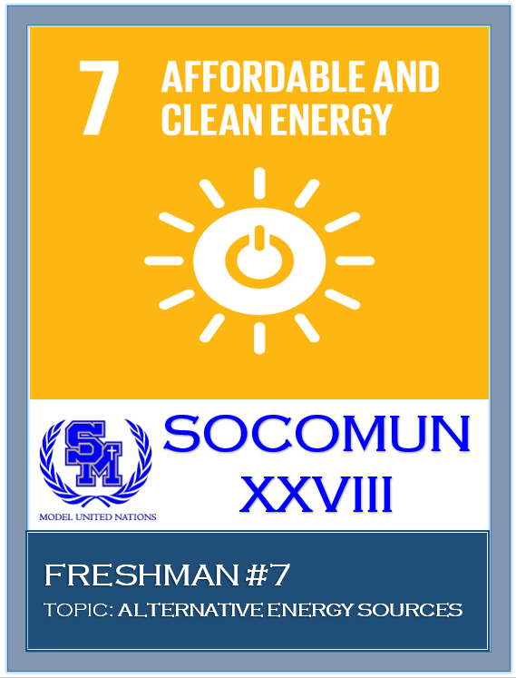

Freshman #7
Alternative Energy Sources

Hello delegates! My name is Elizabeth Emanuel and I am going to be your co-chair for Freshman #7 at SOCOMUN. I am a senior at SMCHS, and this is now my fourth year in Modeled United Nations. I have never regretted my participation in MUN because the program has taught me so many things. MUN has improved my public speaking skills, introduced me to so many new faces, advanced my researching skills, and taught me how to work extremely well with others. MUN has exposed me to so many different opportunities such as traveling, working with different people, and experiencing new places. Outside of MUN, I am involved in choir, manage the boys’ soccer team, lead at my church, and enjoy surfing and going to the beach. I look forward to seeing you all at the conference!
Hello, my name is Sophie Tran and I will be your vice chair at SOCOMUN this year. Currently I am a junior here at Santa Margarita and I have been doing MUN all three years of high school. Being in MUN has helped me become more aware of the problems faced around the world. On top of raising my awareness of international problems, it has improved my public speaking skills, and has enabled me to be more comfortable speaking to a larger crowd of people. Especially during caucusing and while delivering speeches. I am on the dance team here at SM and spend most of my time dancing. I hope SOCOMUN will be a fun learning experience for you and encourage you to continue MUN in the future. See you there, good luck!
Hi, my name is Chloe Vautrin and I am the rapporteur for this committee. I am currently
a sophomore at SM and this is my second year in the MUN program. MUN is a great experience
because of the different and interesting people you meet and because of the public speaking and
research skills you learn. Outside of MUN and school, I play lacrosse, volleyball and hang out
with my friends.
The goal of this conference is to guide freshman who are new to the MUN program and ease them into the flow of how conferences work. As the conference begins, delegates will propose and discuss the possible solutions for alternative energy resources they have researched through speeches. To experience full and correct participation, it is best that delegates propose solutions in agreement with their country’s policies. As the speeches progress, caucuses, informal meetings, will take place for delegates to discuss and compare their solutions. The delegates will form resolutions, papers summarizing the solutions, throughout the caucuses. As this entire program and process is newer to a great number of you, please do not hesitate to reach out to me with any questions or concerns: socomunfresh7@gmail.com

Background:

Clean and affordable energy can be defined as resources that are harmless toward the environment and renewable to all. These resources are environmentally friendly due to their separation and distinction from fossil fuels. The main fossil fuels include coal, oil, and natural gas and when burned, emit toxins and dirty chemicals into the environment. This pollution affects the wellbeing and health of the population, as it increases global warming and distresses climate. The conflicts with energy sources first began along with the production of the first automobile, when petroleum was the most used fuel worldwide. Power-plants became larger as the distribution of automobiles became wider and the need for fossil fuels increased. The prices of the wanted fossil fuels skyrocketed and remain high today as more chemicals pollute the sky every day.
Examples of present-day and commonly known renewable energy sources include solar power, wind power, geothermal power, and hydroelectric power, all acting as the vital sources of energy across the world. These resources strive to restore the atmosphere back to what it was prior the damaging toxins and chemicals. Another source of energy is biomass, defined as organic material coming from plants and animals. It contains stored energy from the sun and releases heat when burned. With the proper approaches and formulations, these renewable sources of energy can reduce the tremendous amounts of pollutants in the air.
Implementing these sources of energy into countries across the world is the best possible solution for reducing the use of fossil fuels in the environment. However, it is out of reach and almost impossible for some nations to apply due to the cost, convenience, and urgency they may hold. Clean and renewable sources of energy, although the safest and least harmful proposal, tend to be expensive and an impossibility for struggling nations. Another issue with the implementation is convenience, as many nations have fossil fuels easily-accessible and in proximity. Lastly, implementing these renewable sources would be time-consuming and some nations are in urgent need of a cleaner and safer environment. While understanding all the weaknesses the resources have, it is crucial that nations focus on the positives and advantages of the integration of the sources.

Possible Solutions:

The following solutions act as examples for what delegates should prepare to work with throughout committee. Delegates must know that in order to do well in committee, they will need to propose original solutions with creativity and build off the following. It is vital that the delegates’ solutions coincide with the policies of their country to ensure they are accurately representing their nation. It is important that the solutions focus on current events that have occurred and areas where the implementation of renewable energy sources is more complicated. Delegates should also remember that there is no need to speak about any funding-related aspects with the resources, seeing that those are handled by the Fifth Committee and World Bank.
Within the world today there are a series of solutions that can aid in the effort to promote affordable and clean energy. Initially it is important for nations to continue their research and development of scientific analytical centers as these centers often provide insight on potential alternatives to harmful energy sources. These alternatives include wave energy, wind energy, biomass energy, tidal energy, geothermal energy etc. Through using private sector funding and donations from other nations this solution would pose as extremely beneficial for many countries. Education is also an extremely important solution to the issue we are facing; however, delegates should not simply state the intention to educate. It is important that different means of education are explored and formulated possibly upon a biannual conference. Through the collaboration of nations, alongside experts in the field of renewable energy, individuals will gain a better understanding on the topic posing as beneficial in the long run. Another potential solution that delegates should look into is supporting the many existing NGO’s and organizations that focus on identifying alternative energy sources. Support can come through monetary donations, donations of equipment, etc. These are merely suggestions to provide delegates with some guidance in creating their own solutions. The following questions below should also be considered:
- Does your nation currently utilize any alternative energy resources? If so, what types and when did they begin.
- Has your nation attempted to use renewable energy sources?
  - Were they successful?
  - What impact did it have on the nation.?
- Seeing as many nations lack a strong infrastructure, can your nation afford to switch towards renewable energy and alternative energy sources?
  - Some of these resources are quite costly, what financially conscious solutions can your nation provide?
- Is there any existing research that your nation has conducted in terms of potential breakthroughs in regard to renewable energy?
  - Are there any scientific research centers within your nation?
- Are there any organizations within your nation that work to promote renewable energy sources? Does your nation provide aid to them?
  - Which organizations, what do they focus on?
- Are there past resolutions regarding this topic that could be revised to pose as plausible and beneficial today?
  - Which resolution? What does it call for?
  - What would your nation want to alter within the resolution to make it better?
    - Why is it better?

Goal 7 Targets. Ensure access to affordable, reliable, sustainable and modern energy for all
7.1 By 2030, ensure universal access to affordable, reliable and modern energy services
7.2 By 2030, increase substantially the share of renewable energy in the global energy mix
7.3 By 2030, double the global rate of improvement in energy efficiency
7.a By 2030, enhance international cooperation to facilitate access to clean energy research and technology, including renewable energy, energy efficiency and advanced and cleaner fossil-fuel technology, and promote investment in energy infrastructure and clean energy technology
7.b By 2030, expand infrastructure and upgrade technology for supplying modern and sustainable energy services for all in developing countries, in particular least developed countries, small island developing States and landlocked developing countries, in accordance with their respective programmes of support

MUN Impact

We hope that you learn a lot about Model UN at our conference. We also hope that you learn about the world we live in and want to make that world a better place for everyone. Consider taking the next step and becoming a part of the MUN Impact Program http://munimpact.org/

To see what MUN Impact is doing related to SDG #7 look here http://munimpact.org/sdg-7/

Works Cited
“A Short History of Energy.” Union of Concerned Scientists, www.ucsusa.org/clean_energy/our-energy-choices/a-short-history-of-energy.html.
This website provides details and facts of how issues with energy resources came about. It can be used while first researching what the topic is about and while writing the background section. This source can link you to other previous occurrences relating to the topic of renewable energy sources.

Renewable Energy Sources - Energy Explained, Your Guide To Understanding Energy - Energy Information Administration, www.eia.gov/energyexplained/?page=renewable_home.

This article is a good source to use to find more information regarding different types of renewable energy sources and how they are used. It would be beneficial when writing about possible solutions or providing background. While this is a good way of getting information on the energy sources, much of the data is based on the United States.

“Benefits of Renewable Energy Use.” Union of Concerned Scientists, www.ucsusa.org/clean-energy/renewable-energy/public-benefits-of-renewable-power.

This source focuses on the benefits of switching to renewable sources and provides data on the number of tech companies which use non-renewable and renewable energy sources. This source provides the reader with information on the benefits of renewable energy including improved public health, inexhaustible energy, and economic benefits. The source focuses on less obvious problems being solved which would help to incentivize countries with various beliefs and various focuses to agree with the solution.

“Affordable and Clean Energy: Why It Matters.” Www.un.org, www.un.org/sustainabledevelopment/wp-content/uploads/2016/08/7_Why-it-Matters_Goal-7_CleanEnergy_2p.pdf.

This UN article presents each aspect of Development Goal 7 and the issues along with it. It delivers an international prospective on the importance of affordable and clean energy. The goal of Sustainable Development goal 7 is to ensure that everyone has access to reliable, affordable, and sustainable energy. Energy plays an important role in our daily lives and supports several economic developments.

“Why Is Renewable Energy Important?” Renewable Energy World , www.renewableenergyworld.com/index/tech/why-renewable-energy.html.

This resource emphasizes and explores different aspects as to why this topic is important. This website would be great to use when writing about solutions due to its mention of home life situations and its collaboration with other organizations throughout the site. The source also offers basic and interesting information about the topic itself.

“Government Solutions.” Public & Private Sector Solutions, www.p-pss.com/whyppps-government/.

This site offers insightful information about private and public sectors. It gives detail about what they are, what their goals are, and the connection between the two. The site is completely unbiased and extremely helped me write my solution about private sector funding when I needed information.

“Energy - United Nations Sustainable Development.” United Nations, United Nations, www.un.org/sustainabledevelopment/energy/.

This resource provides basic data, statistics, and information about the topic of affordable and clean energy itself. The site speaks of Sustainable Development Goal 7, as it is focused on universal access to energy, energy efficiency, and increasing the use of renewable sources. This site is very useful when researching for background and targeting the Sustainable Development Goals.

Krieger, Lisa M. “Why Fossil Fuel Emissions Are Increasing - Again.” The Mercury News, The Mercury News, 6 Dec. 2018, www.mercurynews.com/2018/12/05/why-fossil-fuel-emissions-are-increasing-again/.

This source expands on the prevailing issues of green house gases. The article relates renewable energy sources to these green houses gases and highlights possible solutions for the pollution and emitted chemicals. This site is great and very helpful for writing about both solutions and background.
Iisd. “Policy Brief: NGO Brief: Working Together for Better Implementation of Global Agendas | SDG Knowledge Hub | IISD.” SDG Knowledge Hub, https://sdg.iisd.org/commentary/policy-briefs/ngo-brief-working-together-for-better-implementation-of-global-agendas/
This article provides information and details about a variety of Non-Governmental Organizations working collaboratively regarding the topic. It offers information such as the names of the NGOs, how they work together, and how they have acted on the lack of renewable energy sources. This site was helpful when I wrote about NGOs working collaboratively and increasing their research and analytical data.
“Clean Energy.” Energy.gov, www.energy.gov/science-innovation/clean-energy.

This website provides specific examples of possible renewable energy sources that could eventually replace the current energy sources. The resource gives an adequate amount of detail about how the resources work and how they are environmentally friendly and nonharmful. This site would be helpful when finding specific sources for solutions or when receiving education about different forms of renewable energy sources.

