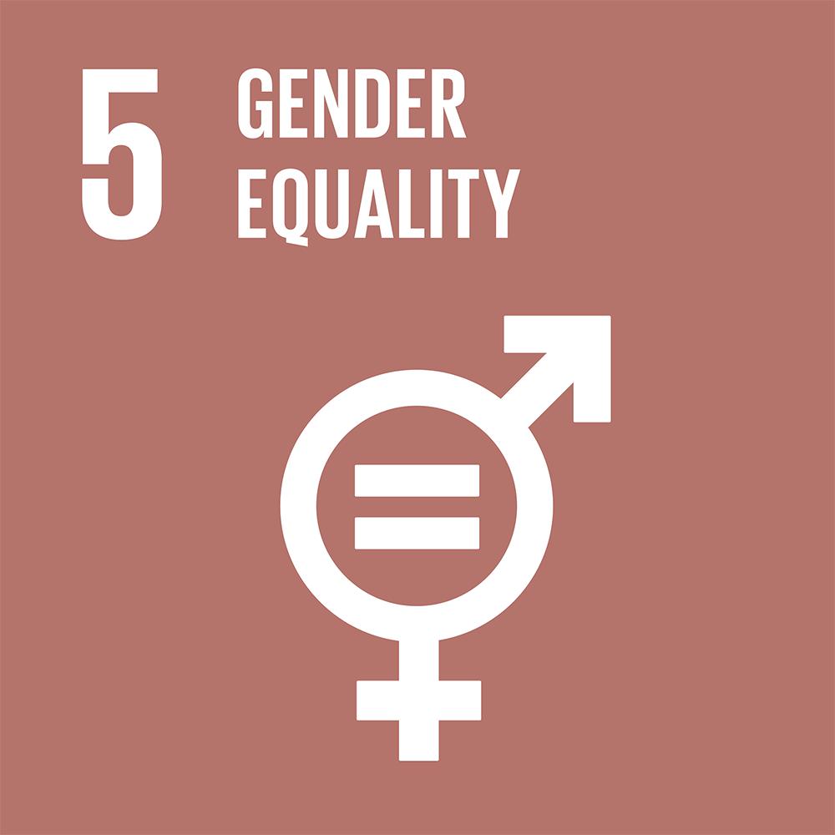
Freshman #5
Freshman #5
TOPIC: Gender Equality in the workforce

SOCOMUN XXVII
Gender Equality in the Workforce
Hello delegates, my name is Caitlyn Mayes and I will be one of your co-chairs at SOCOMUN this year! I am currently a senior at SM and it is my fourth year in the MUN program. I love MUN both as a delegate and chairing and helping out with conferences. I believe MUN perfect to get people out of their shell and preparing them for college and later life. For me, MUN has given me the confidence to speak in front of people and be able to work and collaborate with other people easily. My favorite committee to be a part of in MUN is Security Council because it emphasizes very topical and pressing issues, and the only the Security Council can take direct action. I am especially intrigued by the topic we will be debating in the conference due to its relevance in today’s society and the multiple factors that contribute to the issue. This is my fourth year participating in SOCOMUN and my second year chairing. I have been lucky enough to be able to travel for MUN in my 4 years of debating. My sophomore year I was selected to go to the Georgetown MUN conference in Washington D.C. My senior year I was able to travel internationally for MUN when I attended Royal Russel MUN in London, UK. In addition, I attended UCSB MUN and will be travelling to Prague to attend a Model UN conference there! Aside from MUN, I enjoy spending my free time watching Netflix and playing soccer.
Below are the introductions for some of the people who will be helping to make committee fun and will help the day run as smoothly as possible!
My name is Evelyn Driscoll and I will be the secretary during committee. I am currently a sophomore at Santa Margarita. I am involved in the Talon Theater and Thespians program. I joined MUN last year and found an interest in debating worldwide issues and their solutions. It has improved my public speaking skills and I enjoy learning new things. I look forward to meeting you all and discussing the issue of gender equality in the workforce!
Hi, my name is Madeline Allison and this is my fourth year in the MUN program. I like MUN because it helps your public speaking skills and allows you to meet new people. I have been on one MUN trip to Philadelphia last year. This was a highlight of my junior year; I loved being able to travel to Philly and still be able to compete in MUN on such a competitive level. Outside of MUN, I play both varsity softball and tennis. I look forward to meeting all of you!
I hope that you all use SOCOMUN as a learning experience and a chance to really get involved with the Model United Nations program! It is important to remember to be prepared and well researched- if you know the topic well you did do great! Most importantly, have fun! Use this committee as a learning experience for your later MUN conferences, it will be very beneficial for you if you do. While it is important to research a general overview of gender equality, in committee we will be specifically focusing on gender equality in the workforce, so be sure to have solutions focusing on in the workforce rather than gender equality as a whole. We will start committee by opening debate. Once debate is open we will be entertaining speeches in which delegates state their policy and solutions that reflect their policy. Throughout committee, we will be entertaining motions for informal caucus. Informal caucus will be time for delegate to walk around the room and discuss their solutions with the other delegates. During this time delegates should form resolution groups and start to write their resolutions that list all of their combined solutions. Make sure you are familiar with the topic and with your country’s policy and propose solutions based on your country’s policy. If you have any questions at all don’t hesitate to email me at socomunfresh5@gmail.com. I am looking forward to a great committee!

Background:
Gender Equality in the workforce has been a longstanding issue for hundreds of years. This topic encompasses, but is not limited to, the integration of women into the workforce, the requirements needed to be hired and included in the workforce, and equal wages (based on hours and labor) for men and women alike. Religious traditions and beliefs are integral when understanding the reasons for low percentages of women within the workforce. In various religions, the traditional beliefs and, in some cases, the laws of that country prevent women from being properly included in the workforce or even receiving the education to work. For example, in many Middle Eastern nations, without the permission or accompaniment of a man, women cannot travel, work or register to vote. While not specifically stated in many places, women are not allowed to join the workforce and are not hired when they try to become independent by obtaining their own job. In addition, in both developed and underdeveloped nation’s societal norms have affected equality for women in the workforce. There are many reasons why women are not seen as equal within the workforce, but the fact that in many regions and countries women are still perceived as inferior to men and not as capable, smart, strong, or worthy of a job, especially a high paying or important job such as a position in a large company, is pivotal. This social norm has been proven untrue as seen in the United States where 37.1 percent of women hold at least a bachelor’s degree compared to 34.9 percent for men according to the International Labor Office (ILO). In recent years, the HeForShe initiative has been very popular worldwide, as it urges gender equality on a global scale, which is one of the sustainable development goals. This initiative has not only brought to light the issues surrounding gender equality, such as in the workforce, but it has also encourages various United Nations member states to also take action in their own country to achieve gender equality. For example, in Australia, equal opportunities in the workforce are being promoted worldwide. Previously, men had significantly more jobs than women in Australia, but with a national effort, more women are included and involved in the workforce, however, issues such as equal pay for women and men are still prevalent. Advancements have been made to improve gender equality in the workforce, however, many issues still remain. The United Nations has passed various resolutions to improve gender equality such as Security Council resolution 1325 which highlights that peace and security for women is an opportunity to promote women’s role at the negotiation table and in peacebuilding work. In addition, in 1979 the Convention on the Elimination of All Forms of Discrimination against Women (CEDAW) was adopted by the UN General Assembly. It is often recognized as an international bill of rights for women. It defines what constitutes discrimination against women (including discrimination in the workforce) and sets up an agenda for national action to end it. Also, at the 1995 Fourth World Conference on Women in Beijing, The Beijing Declaration and Platform for Action was established and has since been adopted by various different nations who committed to measures in twelve critical areas of concern, with the assistance of the UN, various NGOs, and regional and international institutions. However, despite all these advancements, the issue still persists. The gender pay gaps still exists worldwide including in developed nations. According to public information collected by the International Trade Union Confederation (ITUC) and published by the ILO, or the International Labor Organization (which is a branch of the UN) the global gender pay gap ranges from 3 percent to 51 percent with a global average of 17 percent (ITUC 2009). According to the United Nations Secretary General, twenty years ago, 12 per cent of parliamentarians in the world were women. Today, 22 per cent of Members of Parliament are women. While this is still a significant increase (nearly double) it is not enough, as it is still only a ratio of 1 to 5. In addition, in the United States in 2010, there were approximately 65 million women in the labor force and 53 percent of these women were concentrated in the following three industries a) education and health services, b) trade, transportation and utilities and c) local government. This shows that while women are being employed more, improving equality, they are still only accepted to a few concentrated positions, which causes overrepresentation for some positions and underrepresenting in others. This discrepancy provides more issues for reducing gender inequality and is not the proper way to go about combating this problem. Recently, there has been a nationwide call for more women within the scientific workforce. A recent study of the STEM field found that most academic journals published have been by males. According to the study by PLOS Biology, the scientific fields with the lowest representation by women were: math, surgery, computer sciences, Physics, and chemistry.

Possible Solutions:
Here are some solutions that will get you started on your research and should give you ideas for further solutions. Try to not just copy the solutions, but build upon them and come up with new ones for committee. All solutions you propose should emulate your countries policy and be plausible. For example, Iran would not necessarily support the implementation of laws that mandate that women are hired just as much as men and you could not just demand all countries hire women equally- consider how you would accomplish this. Also ensure that the solutions proposed within committee are very well developed and can be discussed even more in depth with the other delegates in caucus. If someone in the committee has a question on your proposed solution you should be able to accurately and thoroughly answer. It is important to remember when writing solutions that this is not just an issue for underdeveloped or Middle Eastern nations, it is an issue that is still prevalent in nations such as the United Kingdom and the United States, so ensure all solutions can be beneficial for all nations, not just a select few. It is important to include all nations and look at this issue from a global perspective to be able to fully combat it on a worldwide scale, not just country wide or in developed nations only. In writing resolution papers, make certain that your country’s policy is accurately reflected. When writing solutions, it is very helpful to think of who, what, when, where, and why… these will enable you to have very comprehensive and thought out solutions. In addition, issues of monetary funds should not be focused in in this committee, as that is an issue that is more addressed in the World Bank and/or in the United Nations’ Fifth Committee.
Within a variety of countries, a quota system, can be set up in order to equalize the amount of women and females within the working population. This solutions will not necessarily made compulsory in order to ensure the sovereignty of nations is upheld. However, a strong recommendation to countries to include more females into the workforce will be made. It is possible that nations and businesses in compliance with this solution could receive incentive to promote its integration. This type of quota system would mean the government enforces that a business would have a number of women they are required to employ.
In addition, a universal non-discrimination code can be drawn up that ensures women have equal opportunities. In order to ensure this is achieved peace talks between nations who oppose equal opportunities for women in the workforce and nations who are gender inclusive in the workforce will take place. These negotiations will be an opportunity for nations to voice their concerns, opposition, or promotions for gender equality. The goal would be to form an international agreement about the issue of gender equality in the working field. Ideas for the specifications of what will be included within this agreement can be drawn upon from the already existing laws in a countries such as the United States, Australia, and various European nations who promote the equality of women in the workforce. This code would vary country to country depending on the need for change and the willingness of a country to alter its laws, but the precedent of gender equality that it will set is the first necessary step to solve this issue in the long term.

Questions to consider:
The following are questions for you to consider while you are in the process of researching, however do not need to be specifically asked or answered during the conference.
- How does this issue affect the entire international community?
- All solutions proposed must bear in mind that countries have a sovereignty that cannot be violated. Keeping this in mind, what are some solutions that will promote gender equality in the workforce, while still recognizing the sovereignty of various nations, specifically when respecting a country’s religious beliefs and traditions?
- What is your country’s stance on gender equality in the workforce?
- How will you collaborate with other nations who have an affinity to equalizing the gender gap?
- How will your individual nation contribute to solutions proposed within committee?
- Has your nations or its close allies taken any steps to equalize gender equality within the workforce? If so, what?
- Has the UN taken any actions to help reduce the existence of this issue in the past? What are some of the previously proposed ideas that can be adjusted to be agreed upon and help alleviate the issue of gender equality within the workforce? Do the previous solutions give an idea of new solutions that will actually be agreed upon by the nations within committee?
- Are there any regional, national, or international non- governmental organizations (NGOs) that could be beneficial in to solving this issue and increasing the prevalence of females in the workforce?
- Are there any written laws within your nations that prevent women from being included within the workforce or have factors that still enable the persistence of the gender gap within the workforce (for example, the pay gap)?
- What are some incentives you can offer nations to comply with your solutions?
- How will you get businesses to hire more women?
- How will you convince nations who have not made advancements in gender equality to do so in the workforce?
- How will your nation collaborate with other nations? What treaties, agreements, laws, etc. will you propose, if any?
- How will you address the issue of a lack of educational opportunities that prevents women from receiving equal pay and from obtaining a job?
- What are some solutions that can implemented first in your own country to test their effectiveness, then expanded to other nations worldwide?
Goal 5. Achieve gender equality and empower all women and girls
5.1 End all forms of discrimination against all women and girls everywhere
5.2 Eliminate all forms of violence against all women and girls in the public and private spheres, including trafficking and sexual and other types of exploitation
5.3 Eliminate all harmful practices, such as child, early and forced marriage and female genital mutilation
5.4 Recognize and value unpaid care and domestic work through the provision of public services, infrastructure and social protection policies and the promotion of shared responsibility within the household and the family as nationally appropriate
5.5 Ensure women’s full and effective participation and equal opportunities for leadership at all levels of decision-making in political, economic and public life
5.6 Ensure universal access to sexual and reproductive health and reproductive rights as agreed in accordance with the Programme of Action of the International Conference on Population and Development and the Beijing Platform for Action and the outcome documents of their review conferences
5.a Undertake reforms to give women equal rights to economic resources, as well as access to ownership and control over land and other forms of property, financial services, inheritance and natural resources, in accordance with national laws
5.b Enhance the use of enabling technology, in particular information and communications technology, to promote the empowerment of women
5.c Adopt and strengthen sound policies and enforceable legislation for the promotion of gender equality and the empowerment of all women and girls at all levels

Works Cited:
Huang, Georgene. “2017 In Review: The State Of Gender Equality In The Workplace.” Forbes, Forbes Magazine, 26 Dec. 2017, www.forbes.com/sites/georgenehuang/2017/12/26/2017-in-review-the-state-of-gender-equality-in-the-workplace/#150bb9d14bc6.
This article’s facts are reliable and are easy to understand. It is based around a sample of people in the work place getting their opinion of gender equality in the work place. It also contains insightful facts about how men and women truly feel in the work place as well as how they differ when looking for jobs. Reading this article helped provide great background and a deeper understanding for how both men and women feel in the work place.
“What Are the Roots of Gender Inequality? Women's Rights, Race and Reproduction.” Newswise = Smart News Connection, Arizona State University College of Liberal Arts and Sciences, www.newswise.com/articles/what-are-the-roots-of-gender-inequality-women-s-rights-race-and-reproduction.
This article gives great background that explains the roots of Gender inequality. It helps one better understand the mentality and history that surrounds this subject. This sight is reliable because it gives a work cited as well as accurate facts. Overall this article is helpful and efficient when describing the history of the given topic.
Kamrany, Nake M., and Catherine Robinson. “The Global Problem of Gender Inequality.” The Huffington Post, TheHuffingtonPost.com, 11 June 2012, www.huffingtonpost.com/nake-m-kamrany/gender-inequality_b_1417535.html.
This article explains how wide spread this problem is. It gives statistics that is applicable worldwide, which not only gives helpful background but also a better understanding of which countries lack progress regarding this topic. Overall this article helped me to better understand how severe and widespread this problem is.
Jackson, Robert Max. “Seminar: What Causes Gender Inequality?” What Causes Gender Inequality? -- Robert Max Jackson, www.nyu.edu/classes/jackson/causes.of.gender.inequality/.
This article tell the reader how gender inequality is caused and how to prevent workers from having a sexist mindset. This article is helpful for writing possible solutions and better understanding the depth of this topic. This article helped me understand how to change one’s though process when it comes to women in the work place and how to create a safe environment.
Krivkovich, Alexis, et al. “Women in the Workplace 2017.” McKinsey & Company, www.mckinsey.com/global-themes/gender-equality/women-in-the-workplace-2017.
This article contains information dealing with women worldwide, of different colors and ethnicity, regarding their experience in the work place. It gives powerful statements and facts to back them up with which makes for a reliable source. Overall this source gives reliable, hard hitting facts that help one better understand how many women are still being treated poorly.
“Main Causes And Consequences Of Gender Inequality In The Workplace.” Main Causes and Consequences of Gender Inequality in the Workplace, myassignmenthelp.com/free-samples/main-causes-and-consequences-of-gender-inequality-in-the-workplace.
This source is a research paper on the causes, effects, and solutions of gender inequality in the workplace. It delves into how gender inequality in the workplace is due to all sex discrimination. This source does not have a clear bias and looks at the problem with an objective point of view. This source will help when writing the background because it highlights the negative effects of gender inequality, the causes, and a few solutions. It will also help when formulating solutions because of how it delves into the causes.
Player, Abigail. “Gender Equality: Why Women Are Still Held Back.” The Guardian, Guardian News and Media, 6 Dec. 2013, www.theguardian.com/business/economics-blog/2013/dec/06/gender-equality-women-stereotypes-stop-progress.
This source talks about the reason women have less equality in the workplace: gender stereotypes. It also has good factual statistics on the unfair disadvantage women have in the workplace. This source is objective and has no clear bias. This source will be helpful when writing background because of its effective statistics and percentages it gives of what field of work women are in. It will also assist in writing solutions because it argues that by limiting gender norms and stereotypes, women will gain more rights in the workplace.
“UN Launches 'Platform of Champions' to End Gender Pay Gap.” United Nations, United
Nations, www.un.org/sustainabledevelopment/blog/2017/03/un-launches-platform-of- champions- calling-to-end-global-gender-pay-gap/.
This source tells of how the UN created high-profile network addressing the need to end the gender pay gap. It highlights what they created and its goal. This source is objective as it just tells of the event. It is helpful because of its specific focus on the gender pay gap. This source will be useful in the United Nations involvement as it tells of a specific thing the UN has done to get involved. It also speaks a little about the gender pay gap which can be useful when writing the background.
“Equality at Work: The Continuing Challenge.” UN Women,
www.unwomen.org/en/news/stories/2011/6/equality-at-work-the-continuing-challenge.
This source tells of how an article highlighting the UN Women's stance and ideas on gender inequality in the workforce. It says how they believe that joining and working closely with the International Labor Organization (ILO) is necessary to end gender inequality in the workforce. This source has no clear bias as it simply tells of the UN Women joining with the ILO. This will help when writing the United Nations Involvement part because it tells of UN Women's stance on the topic and how they are going to, along with the ILO, end the problem.
Trachsel, Helena, and Office for the Equality of Men and Women of the Canton. “Six Ways to Fix Gender Inequality at Work.” World Economic Forum www.weforum.org/agenda/2014/10/six-ways-fix-gender-inequality-workplace/.
This source includes very effective ideas for how to solve the issue. It highlights six ways that women can gain greater access in the workforce. Furthermore, the solutions they address are realistic and each have evidence to how the solution will help. There is no clear bias in this source. This source is helpful because it brings up some ideas that others might not think about. This article will also be extremely helpful when writing about possible solutions. It tells of six ideas that are a little broad, but with these ideas a specific solution can be created.

