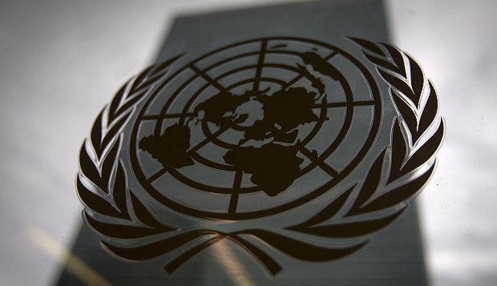
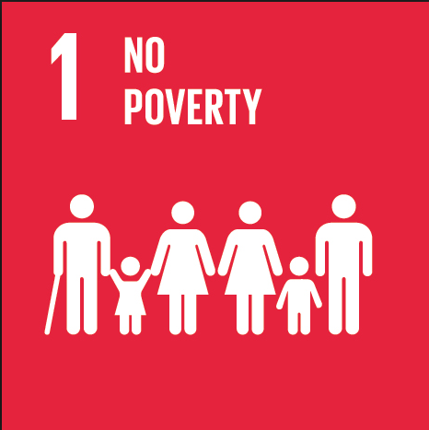
Freshman #1
TOPIC: Providing health services for the poor

SOCOMUN XXVI

Freshman #1
Providing Health Services to the Poor
Hello! My name is Amanda Wilson, and I will be one of your chairs at SOCOMUN. I am a senior here at Santa Margarita, and this is my fourth participating in the MUN program in high school. MUN has always been one of my favorite academic activities, especially since I enjoy public speaking and researching complex issues. MUN has brought me to conferences locally, where I can interact with familiar faces year to year, and it has also brought me to conferences across the country, from the University of California, Berkeley to Yale University. When not going to MUN conferences or writing position papers, I am a member of the Chamber Singers choir and an active member of my church, Holy Trinity, in Ladera Ranch, CA.
Model United Nations is an exciting and engaging experience. In committee, we will be debating the complex and unique solutions that each of you propose as a way to provide health services to the poor. With speeches and caucuses, each of you will have the opportunity to share with the delegates as a whole or in small groups how your country perceives the issue and in what ways you are seeking to solve the problem. Be sure, when researching the topic, to find solutions that may face several parts of a problem, and be sure to address your own country’s needs and resources so as to stay on policy. I look forward to meeting each one of you at this conference! If you have any questions about anything from how the committee will work to logistics on the conference, please do not be afraid to reach out by emailing me at socomunfresh1@gmail.com.
Hi! My name is Hailey Brown, and I will be your legal at SOCOMUN. I am a junior, and this is my third year in the Model United Nations program. I have traveled this past year to UCSB and am looking forward to travelling to the University of Pennsylvania this year. I hope this conference is a great learning experience for all of you as you grow in your speaking and research abilities. Best of luck delegates!
My name is Katie Alker, and I am a sophomore here at SM. I will be the committee’s secretary. I play cello in our school’s orchestra and play stand up bass in jazz club. I am also bass captain in our marching band. This is my second year in MUN, and it has been so much fun so far. I’m so excited to continue. Although it has been frustrating at times, my MUN experience is something I would be reluctant to give up.
Background
Roughly one billion people live in poverty, and a significant number of those people live their lives in disease or forced to take care of someone who is suffering. At least 80% of humanity is forced to live life on less than $10 a day. Poverty and poor health are linked to a variety of reasons. Poor health can be caused by poverty. Political, social, and economic injustice may bring about a decline in health. The living conditions that those who live in poverty face are overcrowded and most likely could not be considered a proper shelter. In this environment, there is a great opportunity for airborne diseases to spread. The biggest killers, especially to those in poverty, are HIV, diarrhea, tuberculosis, malaria, and pneumonia. Billions of dollars are lost every year as a result of these diseases. Malaria reduces economic growth by 1.3% and costs around $12 billion in lost GDP. Without any shelter or safety, many people go without clean water, food, and proper sanitation. Malnutrition is a common killer among those living in these conditions because of the lack of resources. From birth to the age of five is a critical time for the development of a child, and many who lack the access to the necessities of life find themselves disease stricken and dead before they can mature. According to UNICEF, 22,000 children die due to poverty related issues, including malnutrition and diseases. Alongside the diseases that are popular, about one billion lives are affected by neglected tropical diseases, such as leprosy, lymphatic filariasis, and onchocerciasis. Poverty can bring death by disease.
Poor health can cause poverty, as well. Marginalized groups, those that are discriminated against, especially indigenous populations, lack the access to proper health care. Nearly one billion people entering into the 21st century did not know how to read a book or sign their names. How can someone be expected to understand treatments and diseases if they have never had proper education? These groups are denied information and resources that may save their life. Many people living in this scenario are forced to make difficult decisions in how to address life-threatening ailments without any opportunities or money. The cost of treating any health problem is high due to doctors’ fees, treatment options, and transportation. To cover this cost, many families rely on the dominant female of the household. This woman most likely will have to give up her schooling to simply take care of the dying member. She may also have to take up a wage-earning job to support the family while another income is used to pay for the medical bills.
This problem surrounding the world needs to be stopped and needs to be fixed. There is a great number of things to be done, and it is our job to find these solutions.
Possible Solutions
One possible solution to be used to provide health services to the poor includes the implementation of the work already being done by the Health Poverty Action organization. This group works to reduce malaria levels by increasing a community’s access to prevention and treatment, to reduce the effects of tuberculosis by getting patients diagnosed and treated, to stop the spread of HIV, and to highlight the importance of tackling the structural causes of poverty. Many of the actions already developed by this organization are important to remember when developing solutions to be discussed at the conference.
The World Health Organization is currently working extensively to tackle the issues of health in the impoverished communities of the world. WHO helps now to design and implement ‘pro-poor’ health policies in developing countries, which would help to prioritize and respond to the needs of the poor population. While being a renowned NGO, WHO brings about global advocacy, supports regional initiatives, and participates in direct support. A large part of this group’s solution to this problem comes in with the Poverty Reduction Strategy Papers. This organization can be a powerful tool in finding major solutions to ending the poor health that survives in impoverished communities.
A very common medical organization that already works in the field of protecting impoverished citizens from poor health is Doctors Without Borders. This organization provides emergency medical care to millions of people in more than sixty countries across the globe. There are more than thirty thousand staff in the field on any given day, and in 2014, Doctors Without Borders met with more than eight million patients. Areas of high participation are Syria, South Sudan, the Central African Republic, the Democratic Republic of Congo, Pakistan, Yemen, Iraq, and Afghanistan. A team of doctors from around the world sent into places that are in dire need of protection from and treatment for disease has proven to be an effective and efficient solution to providing health services to the poor.
Questions to Consider
When researching this topic for the conference, look below to find some thought-provoking questions that may help to guide you in a particular direction which may bring about unique and constructive debate in committee.
- While poverty is a global issue, seeing as over a billion people are living in conditions where they earn less than what is equivalent to one American dollar a day, how can initiatives be directed toward particular areas of the world? Are there unique solutions to each continent or geographic region?
- How can solutions directed at fixing the economy or directed at balancing the government work to provide health services to the poor?
- Since minorities and discriminated peoples often are not provided with information or resources to take care of their wellbeing, how can social advocacy and the protection of human rights protect health care?
- Using NGOs such as the World Health Organization or Doctors Without Borders may be beneficial, but how can a united front against poor health on a global scale fix the problems that exist?
- How can social media or other creative outlets be used to provide funding and support for this issue?
Remember when researching to use as many trustworthy sources as possible. Be sure to follow to how your country would want to solve this problem. Lastly, to address the problem of funding, the United Nations has its own organization that will provide the necessary funds to develop an initiative. Good luck in preparation, and I look forward to discussion and debate with you soon at SOCOMUN!

Works Cited
Shah, Anup. "Poverty Facts and Stats." Global Issues. Global Issues, 7 Jan. 2013. Web. 2 May 2017.
Simon, Dan. Poverty Fact Sheet: Poor and In Poor Health. London: Child Poverty Action Group, 1978. Web. 21 Apr. 2017.
"Key Facts Poverty and Poor Health." Health Poverty Action. Health Poverty Action, n.d. Web. 20 Apr. 2017.
"Poverty and Health." The World Bank. The World Bank, 25 Aug. 2014. Web. 20 Apr. 2017.
"Poverty and Health." WHO. World Health Organization, n.d. Web. 21 Apr. 2017.
"Types of Projects." MSF USA. Doctors Without Borders, 16 Nov. 2015. Web. 21 Apr. 2017.

