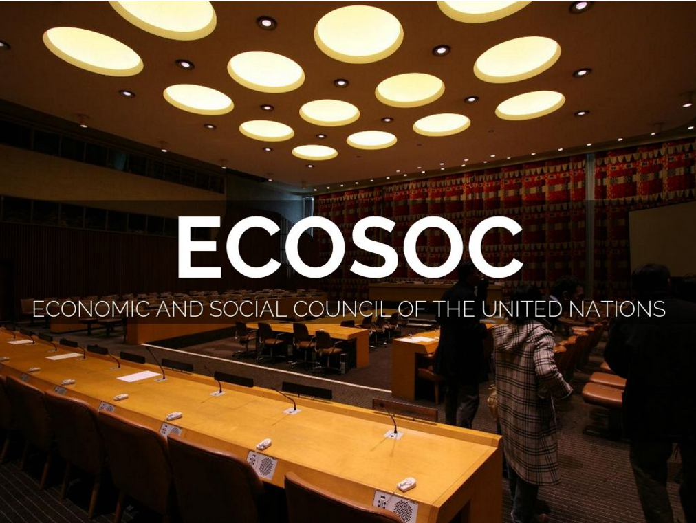

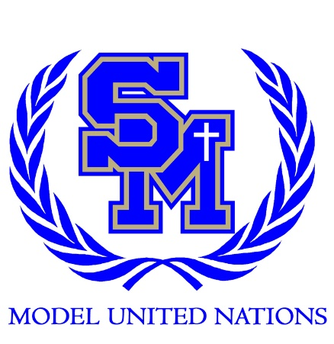
SOCOMUN XXVII

ecosoc
TOPIC: peacebuilding and
post-conflict recovery

Economic and Social Council (ECOSOC)
Economic and Social Counsel (ECOSOC)
Peacebuilding and Post-Conflict Recovery

Hello, my name is Ryan Rupp. I will be your co-chair for SOCOMUN this year! I am a senior as SMCHS, and this will be my fourth year participating in MUN. I have really enjoyed my time during MUN, it has helped me gain knowledge and given me a unique perspective about the world at large. It has helped shape and sharpen my once dull public speaking skills, making it easier for me to speak and interact with both large and small audiences. It also has forged me into a better writer, presenting me with speeches and position papers to write. I prefer to write about topics pertaining to human and drug trafficking, especially those which take place in Latin America like the UNODC. I have participated in many conferences and plan on extending me grasp to more foreign territory. Other than MUN, I am on the trach team for SMCHS and perform at singing competitions in front of large crowds, so as you can see MUN has been extremely helpful in my life.
I hope SOCOMUN is an enjoyable and productive experience for every single one of you, and I hope you choose to continue on in MUN. Now, first we start off with debate, during debate delegates with give a speech containing possible solutions for the topic at hand. We understand that not everyone will be able to fully develop their ideas and solutions in a single speech. So, in order to fully flesh out your ideas it’s best to motion for caucus, in which delegates will mingle about and talk to others in depth about their solutions. In talking to others about your solutions you could form a resolution group with other delegates who have similar solutions to yours with the ultimate goal of making a resolution. A couple of things to stress are that you understand both your country policy and the topic at hand also. If you have any concerns or questions please send me an email at ecosoc.socomun@gmail.com. I hope you enjoy your time at SOCOMUN and good luck!

Background:
Peacebuilding and Post-Conflict Recovery for a nation is one of the most daunting situations facing the world. Trying to build a country back up after a war in terms of its economy and people is extremely difficult. In addition a country must also be able to sustain itself here after. So when rebuilding a country it requires constant international backing to make sure it doesn’t recede or stay in a constant state of chaos. To put this in to perspective countries need support in the displacement of refugees, overseeing ceasefires, and constructing and coordinating government election for a completely new government. These are just a small fraction of problems that need to be taken into account when it comes to peacebuilding and dealing with the fall out of these countries. Civil wars are the most common problem and destructive problem that plaques most countries. With it being estimated that around 20% of all countries have experienced a civil war in some way. Recovering after these devastating events/wars is strenuous for both a countries economy and population. Let’s first give an estimate on how much damage is caused by a civil war. From World War II and onwards civil wars have killed around 16 million people. The average civil war last from 7-8 years. The economy post-civil war is a mess due to the fact that during a civil war countries will receive a low amount of aid from other countries. In addition most of a countries money goes towards its military. To add insult to injury, civil rights are at a higher risk of violation. Post-civil war a countries economy tends to grow a bit more due to country aid being raised. Unfortunately everything else seems to fall flat. As human rights violations are soaring higher and higher everyday with these violations soaring higher than the average country. To combat this type of problem requires a lot of resources and expert planning. To give an idea over 600 peace agreements have been made and an estimated 120,000 UN peace keepers have been sent out to settle these conflicts that have erupted. Why don’t we give an example: Burundi. The Burundi is a country that history parallels Rwanda’s bloody past. With both having similar ethnic groups and massacres. Only diverging in terms of who holds power. With Rwanda having a coercive Hutu government and leading a genocide against the Tutsis. The Burundi government is a repressive Tutsi government and has lead mass violence against the Hutu, leading to a large scale civil war. An extreme amount of people were killed in the Burundi civil war with over 300,000 Burundi civilians dead, only to be finally ended by the Arusha Accords which was implemented only five years later. The peace agreement enforced a balance representation in political positions and in state military. Burundi is just one of the many examples of civil war conflict fueled by rival ethnic groups and hatred. Others are most politically fueled, the conflict in Gambia is a prime example of this. With the ruler Yahya Jammeh refusing to relinquish power, believing that his lost is attributed to voter fraud. Now the country of Gambia is on the edge of becoming desolated by neighboring armies preparing to remove him forcefully if he does not relinquish power to rightful winner of the election Adama Barrow. Yahya Jammeh has been in power for 22 years. With those 22 years being hell for the people of Gambia, as Yahya Jammeh regime has been described are tyrannical government with witchcraft thrown into the mix of it all. An example of this being that one time he “exorcised” an entire village by forcefully feeding 1,000 residents hallucinogenic potions. On top of it all, most of his critics have been put in jail or executed with not a single prisoner ever leaving his jail alive. Now Gambia has been put into the tight situation of staying with a Tyrannical leader or being invaded by the West African Bloc. So what has the United Nations done to prepare to deal with situations like Gambia. Well the United Nation has been in the center of most peacebuilding and post-conflict recovery of nations. It has verified multiple peace agreement in Cambodia, South Africa, and Central America. It has strengthens ties and countries such as the Balkans, West Africa, and even little Timor-Leste. In 2005 the United Nations recognized that it needed to be better prepared and involved in such problems so they authorized the formation of a new Peacebuilding Commission. This Peacebuilding Commission was assigned to determine what is dire and what is not. How much attention a post-conflict country deserves and to pour focus on any conflicts that could undermine the United Nations mission of peacebuilding. In addition to the Peacebuilding Commission the United Nations also authorized a Peacebuilding Fund and Peacebuilding Support Office. With the Peacebuilding Fund supporting actions and programs to build peace and the Peacebuilding Support Office managing the Fund. ECOSOC’s role in all of this is described as being an “avant-garde” or a new/experimental group. In 2002 ECOSOC authorized the creation of ECOSOC Ad Hoc Advisory Groups which helped make long term programmes for support of other countries that have recently moved out of a conflict. This lead to two groups being created, that of Guinea-Bissau and Burundi, both of which have been terminated now due to both having their problems addressed. Now they are focusing in on Haiti and its long term development to create socio-economic recovery within the country, creating Ad Hoc Advisory Group on Haiti. Recently ECOSOC has called on support for South Sudan. Specifically that the Secretary-General comes done and helps assimilate a coordinate plan on how to deal with South Sudan’s struggles.

Possible Solutions:
The following are possible solutions that could be implemented for helping with Peacebuilding and Post-Economic Recovery. I encourage all delegates to work with one another and create your own solutions or improve/build upon one another’s. Take note of your country policy, as to see whether or not your country would be in support of your solution or not. Think about whether or not your country has an agenda that it wishes to implement with in the world. Also take in the fact that some countries have different religious beliefs and some solutions could possibly cause quarrels or riots if a country is particularly religious. Finally, try to take note that MONEY is not a problem. Money is already taken care of by the World Bank and Fifth Committee.
To help countries build up peace and post-conflict recover, when dealing with a country that has gone to war for religious reasons that each group involved in the conflict is given equal representation its government system. Grouping up people who have been in at odds with each other in the same room on the same political platform will encourage interaction between the ethnic groups. Taking them out of their social bubbles. And with social interaction between them they will come to know and understand each other. Humanizing them to each other and becoming a lot friendlier to one another. For it’s harder to attack someone that you know. Not to mention colliding the groups with each other on an equal playing field creating great discourse that will breed innovation and better laws that will be applicable for all in a new government. Next, is the implementation of NGO’s that deal in this line of expertise that can help sustain and comfort a country post-conflict. Next, in order to help expand and fund NGO’s (Non-governmental organizations) incentives should be provided to companies that invest in these NGO’s or in funds that the government themselves set up. Incentives should be tailored made for each country. We call upon International Center for Transitional Justice or the ICTJ. Post-civil war a country will be at an all-time high when it comes to human rights violations. To help combat this the Ford Foundation created the ICTJ. Launched in 2001 the ICTJ has helped countries pursue those who have committed mass atrocities and have abused human rights. The ICTJ has a track record of working with 8 Sub-Saharan countries. It has had a hand in creating the Truth and Reconciliation Commission of Liberia also known as TRC. Which now investigates abuses committed during Liberia’s civil war. It has also engaged with Liberian refugees in the United States as well. They are also responsible for training journalists in Liberia and supporting coverage of undergoing war crimes. There is also the OSI or SOROS Foundations network. OSI or SOROS helps deal with the problem of education within countries struggling post-conflict. It has donated money to many education systems. An example is when it gave 1 million dollars to the LET to help support the building of schools, created programs for women, and also supported the setting up of LET in Liberia. OSI/SOROS also gave over 5 million dollars to the Primary Education Recovery Program as well. It has also created many programs, trained many teachers, and created multiple school. Specifically it helped create 18 schools in 2007 along with LET and helped train 80 teachers in 2007. We also call upon the Revenue Watch Institute which has helped manage resources in the past with countries that have gone through a damaging conflict. They do this by promoting responsible management of oil, gas, and minerals. Also has successfully renegotiated contracts with multiple companies to help other countries in need. They have written many detailed reports on how to deal with peacebuilding and post-conflict recovery.

Questions to consider:

- What is your country policy?
- Has your country dealt with a civil war? If so how did it recover after?
- Could the UN or any other government help these struggling countries?
- How will you promote human rights and Justice in a post-conflict country?
- How will you rebuild the education system within a post conflict country?
- How will you promote the responsible and effective management of a countries natural resources?

Works Cited

“About Us | UNITED NATIONS ECONOMIC and SOCIAL COUNCIL.” United Nations, United Nations,
https://www.un.org/ecosoc/en/about-us
This source explains what peacebuilding is along with background information about ECOSOC. This source states that peacebuilding needs to include trust between individuals and society in order to work effectively without challenges, I think that this source is useful if you are wondering what peacebuilding is and you are looking for background information. Although, this source is good for background information I would not use this source to learn about ECOSOC or to find solutions to peacebuilding.

“UN Economic and Social Council; Resolutions; Decisions. “United Nations, United Nations, www.un.org/en/ecosoc/about/peacebuilding.shtml
This source educates people on what peacebuilding is and explains that is the effort to reduce a country’s risk of going into conflict. It also recognizes that the United Nations needs to respond better to peacebuilding and take more actions to overcome the challenges that come with peacebuilding. The UN website provides useful information about peacebuilding while also explaining what solutions can help overcome the challenges associated. The UN explains that peacebuilding is in need for the Commission to aid post-conflict countries when necessary. I found this source very helpful because It not only helped me understand peacebuilding it contained possible resolutions to the problems with peacebuilding.

“UNITED NATIONS ECONOMIC and SOCIAL COUNCIL.” United Nations, United Nations,
https://www.un.org/ecosoc/en/home
This source explains how ECOSOC brings people together to the solve issues about peacebuilding. This source also explains that ECOSOC is on all three pillars of the sustainable development goals- economic, social and environmental. This source is the UN website and it provides background information about peacebuilding along with background on ECOSOC committee I found this source very helpful because it provides a summary on peacebuilding and offers possible solutions.

Britannica, The Editors of Encyclopedia. “Economic and Social Council.” Encyclopedia Britannica, Encyclopedia Britannica, Inc., 22 July 2013,
https://www.britannica.com/topic/Economic-and-Social-Council
This source explains that ECOSOC or the Economic and Social Council is one of the six organs of the UN. It also states that ECOSOC’s responsibilities include coordinating the economic, social, humanitarian, and activities involving peacebuilding for the UN. This article provides useful information including the fact that ECOSOC was established by the UN Charter in 1945. I think that this source is very useful because it gives important information on the ECOSOC as a whole along with what steps the UN has done for peacebuilding.

Paul, James. “Global Policy Forum. “The Peacebuilding Commission,
https://www.globalpolicy.org/un-reform/un-reform-topics/the-peacebuilding-commission.html

This source explains that the Peacebuilding Commission or PBC was proposed by the Secretary Generals. The Secretary General gave the Peacebuilding Commission a role in post-conflict countries to prevent them from going back into war. This website is very useful because it describes what the PBC does while also explaining the job of the Secretary General. I found recommend this source to others because I believe that it is very useful information that would help others come up with solutions to peacebuilding challenges. Lastly, this source is very credible because it is unbiased and also provides useful information on peacebuilding.

SOCOMUN Annotated Bibliography and Secretary Bio

Guterres, Antonio. “Peacebuilding and Sustaining Peace Report of the Secretary-General.” United Nations. 18 January 2018, un.org, pp. 1–19.
The PDF above is the early 2018 report written by the UN Secretary-General on Peacebuilding and Sustaining Peace. The essay, formed like a Resolution Paper, begins by mentioning past efforts of the UN (specifically the dual resolutions of April 2016), and continues to cite actions and plans the author believes should be carried out. In summary, Antonio builds off of the already put in place solutions regarding the reform of the peace and security pillar, the repositioning of the development system and the shifting of the management paradigm, and how these will contribute to an Organization that is more effective in supporting Member States in preventing conflict and sustaining peace.
I believe this source is crucial for a current and reliable understanding of the current plans set in place for building peace and post-conflict recovery projects. It is a direct source from the Secretary-General, so all information has guaranteed reliability and any bias is simply non-existent.
This is a very helpful source for understanding the direction the UN plans to take peacebuilding and post-conflict recovery in, and it could give students a lot of information in all areas of their papers (excluding country policy). It displays the current opinion of the UN on the topic, and so the source primarily serves as the foundation for opinions to be built off of.
Connolly, Lesley. “A Year of ‘Sustaining Peace’: What Was Learned from Burundi and The Gambia?” IPI Global Observatory, International Peace Institute, 27 Apr. 2017, theglobalobservatory.org/2017/04/sustaining-peace-burundi-gambia-prevention/.
In short, the article above discusses how in the past year (2016-2017) the dual resolutions created by the Security Council and General Assembly have been implemented and beneficial, using Burundi’s and The Gambia’s conflicts as examples. The article delves into specific areas the direction from the resolutions has been proven effective like during electoral transitions and democratic increases, and concludes stating the importance of these two resolutions and the high level of effectivity the author believes the resolutions create.
This source is useful to understand the less recent plan of action taken towards building peace and post-conflict recovery, but in comparison to the newest Secretary-Report seems lacking. The article appears to have a slight bias due to the author being a proponent of the resolutions, but does include facts to back up beliefs using their two examples. The goal of the article is to assure faith in the UN’s action towards the topic and build trust in their later judgement.
In the grand scheme of the topic at hand, this article proves that the Security Council and General Assembly have headed in the right direction towards building peace and improving post-conflict recovery projects. It can be used to see what has been done correctly in the past, to create better solutions for the present, and also begins to form a timeline, which is crucial to understanding any topic, for the steps taken towards reaching our topic’s goal.

Makoond, Anupah. “A Discussion on Peacebuilding and Sustaining Peace.” Ipinst.org, International Peace Institute, 27 Feb. 2018, www.ipinst.org/2018/02/unsg-report-peacebuilding-and-sustaining-peace#5.
This source is basically a discussion on the recent solutions proposed by the Secretary-General in January 2018. The original meeting featured a broad group of member states, United Nations officials, civil society, academia and members of the public, and these participants offered their praise for the proposition the Secretary-General made, as well as included their criticisms or additions.
This article is mainly useful to understand the Secretary-General’s solutions better. It gets your brain thinking of criticisms, important points, and additions san individual believes should be added onto his publication. The goal of the meeting was to discuss the direction the UN was taking in, on the matter at hand. The recentness of the article also contributes to the validity and importance of the article itself.
This article is an addition to understanding what I believe is a very important source, the Secretary-General’s address early this year on the topic. It provides other points to think about, and overall helps shape personal ideas for creating solutions to the ongoing issue with peacebuilding and post-conflict recovery.

“Pax Africana: Peacebuilding in Africa.” Ipinst.org, International Peace Institute, 14 Mar. 2018, www.ipinst.org/2018/03/pax-africana-peacebuilding-in-africa#4.
The article above allows readers to understand specific cases of the countries and people of those countries the topic at hand mainly effects—Africa. The article is a summarization of a meeting between prominent peacemaking figures of the continent. There were differing views and opinions at the meeting, but the overall undertone was simply that more needs to be done to create a peaceful environment for Africa. The article then shows examples of the different areas where ground needs to be made, and finishes stating that this is an opportunity for the UN and the AU to band together to fight the issues at hand.
I believe the importance of this article derives from the fact that it shows the point of view of the people these resolutions effect. The writers of these resolutions, even the Secretary-General believe much ground has been made, but the words of these representatives show to those people, there is still plenty more to be done. As well, it states specific areas where work can be made, and this makes way for opportunities for solutions to be made,
This article fits in best when you consider the people these solutions and resolution effect have their own opinion on the headway being made. This article will allow people to create a better understanding for future progress, not progress that has already been made.

“United Nations Peacebuilding Support Office.” Un.org, United Nations, www.un.org/en/peacebuilding/pbso/pbun.shtml.
The article above, although primary, is the primary starting point researchers mist take in understanding the topic at hand. It gives a brief background on the history of Peacebuilding in the UN and lists the types of people who contribute to the cause.
The article proves it’s use in the way that it creates a basic building block for understanding of all other articles on the topic. The information can be deemed recent, reliable and without bias, and it is a source that gives detail of very early peacebuilding developments in the UN, which is something my other articles do not do.
This article and others like it, are the place researchers must start to truly understand a topic well. This article allows you to build bridges and connections to thing mentioned in other articles, and so it gains its merit of usefulness due to how basic and concrete it is. Reading this at the very end of your entire research process will likely change your view point, as it did me, and truly complete an understanding of peacebuilding and post-conflict recovery.

Secretary Bio
Hello Delegates! My name is Kambiz Shoaei and I’m a Sophomore Model UNer at Santa Margarita. I started MUN last year as a Freshman with absolutely no experience, but I eventually got the hang of it and got to see how fun it can really be. I even get to go to the Berkeley MUN Conference later this year! Other than MUN, I spend my time usually around my friends, at swim practice, or cramming for my next test. I understand this is likely your very first conference, so I wish all of you the best of luck, but most importantly have fun!

