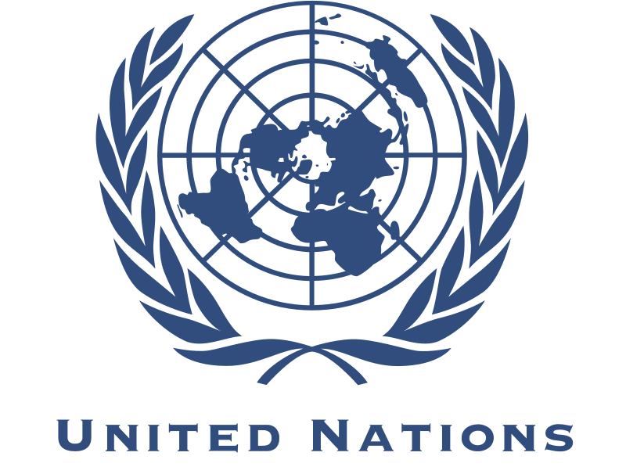
ECLAC
Topic: Migration and Social Protection - access to rights (health, education, work, justice, and family life) for migrants

SOCOMUN XXVIII
ECLAC
Migration and Social Protection

Hi everyone, my name is Lauren Raney and I will be your head chair for the Economic Commission for Latin America and the Caribbean committee for SOCOMUN XXVIII! Currently, I am a junior at SMCHS, and this is my third year in the Model United Nations Program. I am the student chair of the Eagles Edge club on campus which serves to provide high schoolers with an insight into the world of finance. Outside of school, I row at the Newport Aquatic Center. My favorite activities are hiking, being on the water in any way, and going to the beach with my friends. MUN has given me an incredible amount of opportunities. I have made some of my closest friends through MUN, and even had the opportunity to go to BMUN at UC Berkeley. MUN has helped me become more aware of political issues throughout the world, and how we can help to solve them. Personally, I love debating topics regarding human rights and international disagreements. I have learned some of the most valuables skills in my life through MUN such as, problem solving, collaboration and diplomacy, and public speaking skills. My favorite part about MUN is meeting new people and working with them to solve global issues. I hope all of you learn a lot during this conference and feel free to ask me any questions you may have at this email: socomuneclac@gmail.com
Hi, my name is Emily Endraws and I will be your vice-chair for the committee of Migration and Social Protection - access to rights (health, education, work, justice, and family life) for migrants during your time at SOCOMUN. I have been doing MUN for 3 years. I have traveled with MUN to the UC Berkeley conference and I am planning to go to the London conference during the school year. I am very glad to help you all become better at MUN and better understand MUN procedures.
Hi, my name is Tatum Tatch and I am currently a sophomore here at SM. This is my second year in MUN, and along with MUN I like to play soccer and hang out with my friends. I am so excited to be your rapporteur and I look forward to seeing you all in committee.
The SOCOMUN XXVIII conference will begin with an opening ceremony in Moiso Pavilion. Afterwards, you can follow our vice chair or rapporteur to the designated committee room. We will begin committee with roll call to which you will either respond with present or present and voting. Following this, delegates will be able to open debate and the speaker’s list to begin the first round of speeches. The delegate who opens the speaker’s list is usually the first speaker. My co-chair and I will be scoring speeches, and delegates are all encouraged to share a short summary their country’s position on the topic and then explain solutions. We encourage all of you to maintain your country’s position on the topic as accurately as possible throughout committee. At any point up to the chair’s discretion, delegates may motion for formal and informal consultations, which are also commonly referred to as moderated and unmoderated caucus. These formal and informal consultations will provide delegates with an opportunity to further detail their solutions in order to form resolutions and will also be graded by the dais. After each group has completed their resolution paper, a delegate from each resolution group will send the papers to the committee’s email address. Then, we will proceed into formal debate to present each resolution. After each resolution is presented, we will move into voting bloc, in which delegates will vote on each resolution. After dismissing committee, we will all walk back to Moiso Pavilion together for our closing ceremonies. I hope that everyone can debate this important issue while being diplomatic, and of course still have a good time!

Background:

The background should include a historical background of the topic as well as previous actions taken by the international community. Delegates should also include who is involved in the issue and why it is a problem to the world. Be sure to use credible sources and include detailed information in this section of the paper.

On the topic of Migration and Social Protection- access to rights (health, education, work, justice, and family life) for migrants, many aspects of this crisis must be addressed. Migrants are frequently, and without justification excluded from access to basic human rights. Undocumented migrant workers are specifically targeted by lack of social protection under discriminatory and unequal cultural and legal traditions. One of the major issues facing these people is the inability to transfer social security from one nation to another, which specifically affects workers working temporary or informal jobs and their ability to acquire long-term residency benefits. The number of migrants in the area that ECLAC discusses, within the Caribbean and Latin America, has grown at a rapidly alarming rate in recent years. The most common destination for migrants is the United States, while Canada, Europe, and other Latin American nations have also experienced a large influx of migrants. Many migrants come searching for better opportunities for work, fleeing political turmoil or persecution. Many of these grants arrive in their destination with no documentation. Females make up half of this region’s migrants, who are typically traveling alone looking for work. These women are especially vulnerable as victims of trafficking and other exploitation. Many of the migrants who manage to find work, get jobs working in domestic or heavy physical labor. These migrants make up a large percentage of the nations to which they relocate gross domestic product, or GDP. This means that these migrants are an invaluable part of their nation’s economy and yet, they are still frequently lacking the basic rights they deserve. Often a lack of documentation, or an inequality in social security rights provisions leaves these migrants unable to access proper healthcare for them and their family, access to the justice system, education, non-discriminatory access to work, and protection of the rights of their family. Another commonly overlooked migrant group is that of skilled professionals who leave their nation with a smaller economy for better opportunities in more developed economies across the world. Migrants, and the rapid rate at which they are increasing, is a very troublesome issue for the international community and the social protection of their rights is an issue the international community must address immediately.

Possible Solutions:

All solutions proposed in this section of the paper should be in accordance with your country’s policies on the topic. It is important to note you’re your solutions should be detailed; clearly state how the solutions will be implemented, and how they will affect the situation. You can use information about the topic presented in the background, country policy, and past UN actions to help supplement your solutions, as well as how and why they will be successful.

The united collaboration of the international community is of the utmost importance in securing social protection of migrant workers and full access to health, education, work, justice, and family life rights. The International Labor Organization, or ILO, has previously proposed a variety of solutions which have proven ineffective due to poor implementation and lack of international unity in the implementation. To prevent this ECLAC must encourage the creation of a new United Nations sub-committee to ensure collaboration through a bi-annual summit on the topic. This sub-committee will be monitored by the United Nations to ensure all funding is being used appropriately and that international progress is being made. To further protect the right of migrant’s new international legal framework must be implemented. To do this ILO standards of protection of migrant workers must be applied through the encouragement of the ratification of legislation across all nations. To ensure the conclusion of social security discrepancies across nations, social security agreements must be implemented that will allow equal treatment and access to social security programs across national borders. These agreements, once signed will allow for social security programs to be portable for migrant workers as they will still be protected under the same standards regardless of the nation, they work in. The ILO proposes the use of the “Annex of the Maintenance of Social Security Rights Recommendation, 1983 (No. 167)” as a model for the creation of further treaties regarding social security equality. (ILO, Social Protection for Migrant Workers). Furthermore, countries of employment should provide equal treatment for residents and non-residents regarding social security coverage and benefits. Countries of residence may also supply their nationals working abroad with a temporary basic level of rights protection through voluntary insurance. The United Nations must also urge nations to raise the basic level of rights provided through social security to ensure all migrants will be protected in the event of incoordination between nations regarding social security standards. Another aspect of the protection of migrant workers that must be addressed is child migrants, especially those arriving unaccompanied. The first step to ensuring the rights of these minors is for each of them to be screened by welfare professionals to ensure they are placed in safe care. This screening process will also allow for survivors of trafficking and persecution are identified so that they may be provided with the services they need and to receive proper certification. Legal framework must be updated internationally to ensure that children’s best interests are protected as they are unable to advocate for themselves. Oversight and accountability must be increased as well to ensure that all migrants that are in vulnerable situations are not exploited or observed in custody. This can be ensured through the creation of a special task force that operates under the UN with the specific purpose of ensuring safety of those in vulnerable positions and protecting their rights by not allowing those in positions of power to exploit them in any way. Children should also be exempt from the expedited removal process, to allow only voluntary return at a time when their safety can be ensured through consultations with legal professionals. The United Nations should also encourage that each nation creates a national program to provide children with information and to conduct assessments of their current situation.

Questions to Consider

These questions should guide you when it comes to writing the background and policies in your position paper and should be addressed in your solutions. Again, be sure to stay true to your country’s policies regarding each question. You do not have to answer these questions; they are just provided as resource to assist delegates in the creation of more detailed solutions.

- How has this topic evolved through historical timelines, and how has it affected history?
- What are your country’s policies and what actions having your country taken regarding this topic in the past?
- What actions has the United Nations taken regarding this topic and how has it affected the international community?
- Does your nation support or oppose the actions/policies taken by the United Nations? Has your nation acted as a sponsor or signatory on any resolutions regarding this topic?
- What non-governmental organizations contribute to helping those that are affected by this issue?
- How can direct relief be provided to the nations who deal with this issue more predominantly?
- Do your solutions align more closely with the regions not affected by this crisis or those affected?
- How can your country get the international community involved?
- How can you ensure international cooperation on the implementation of your solutions? Why might some members of the international community be opposed to your solutions?
- Does your country agree with the international policy regarding this topic?
- Do any other nations disagree with your countries policy on this topic? If so, why?
- How will your solutions relieve this issue in the long-term and continue to relive the problem?
- Will the overall international community agree with the policies you have outlined in your solutions?
- How will the migrants who are affected by this issue feel about the proposed solution?

Works Cited

“Social Protection for Migrant Workers (Labor Migration).” Social Protection
for Migrant Workers (Labor Migration), https://www.ilo.org/global/topics/labour-migration/policy-areas/social-protection/lang--en/index.htm
This website gives a definitive explanation about the issue of the lack of social protection for migrant workers. Of 232 million immigrants worldwide, 105 million are migrant workers that are struggling for this basic right. These people risk their social security of their native country and face restrictions of their new host country’s social protection system. This website also references the principles from the International Labor Organization (ILO) that define the right of social protection as well as the challenges that face immediate relief of this problem. These should prove to be useful for reference in debate and discussion.
“Migrants.” Social Protection and Human Rights, https://socialprotection-
humanrights.org/key-issues/disadvantaged-and-vulnerable groups/migrants/
This website gives brief statistics about migrant workers worldwide and provides further resources that will give more depth for research. Imbedded in the site, there are expert commentaries about every human’s basic right to social security that is defined in the International Covenant on Economic, Social and Cultural Rights (ICESCR). Legal cases about this topic from Korea, Thailand, Switzerland, and South Africa provide insight on this topic from different countries’ views. These different cases should be beneficial for delegates looking for a global perspective on this problem and how it affects different countries.
“Immigration Policy Solutions: Supporting Child Migrants.” The Opportunity
Agenda, https://www.opportunityagenda.org/explore/resources-publications/immigration-policy-solutions-supporting-child-migrants
This website explores feasible solutions for the acquisition of rights for child immigrants. While most of the solutions given are applicable for US government, all are universal concepts that can be implemented in other countries to help give migrants more social rights. For example, these solutions “Ensure that children and other people in vulnerable situations are not exploited or abused in short-term or long-term custody.” These possible legal policies should be helpful for delegates looking for immediate solutions in their country’s current government or for proposing solutions for countries that deal with more migrants.
Molyneux, Maxine. “Change and Continuity in Social Protection in Latin
América.” UNRISD, 2007. https://www.files.ethz.ch/isn/45959/001.pdf
This essay was published by the United Nations Research Institute for Social Development. It outlines the changes of the social protection policies in Latin America, compares the new and the old policies and forms of social security, and questions whether the changes that were made have helped the pressing issue. The author also examines the role that women play in Latin America and the social rights that they receive. This resource explains past changes in Latin America from the perspective of the United Nations and will be useful in thinking of new actions that the UN could carry out after learning from past successes and mistakes.
Economic Commission. “Human Rights and Development to the Centre of
Debate on Migration in Latin America and the Caribbean.” Press Release | Economic Commission for Latin America and the Caribbean, CEPAL, 26 Dec. 2016, https://www.cepal.org/en/comunicados/derechos-humanos-desarrollo-al-centro-debate-migracion-america-latina-caribe-0
This article from the Economic Commission for Latin America and the Caribbean (ECLAC) shows how numbers of immigrants in various countries have exponentially risen. Immigrants, most notably from Mexico, Colombia, and the Caribbean are flooding into the US, Canada, and countries in Europe. Almost half of these people travel and immigrate without formal and legal documentation. This website provides quick references about immigration and goes further into depth about readmittance and the problems that ensue.
DOE/Argonne National Laboratory. “Worker’s Rights.” Www.undp.org , 2010,
https://www.ohchr.org/Documents/Issues/Migration/DraftPrinciplesAndGuidelinesOct2017.docx
Workers current rights are all listed and finalized and help us fully understand the situation. It helps, by allowing the people to see which rights need to be fixed and amended. It shows the flaws in the system.
“Immigration & Migrants' Rights.” International Justice Resource Center,
ijrcenter.org/thematic-research-guides/immigration-migrants-rights/.
A migrant worker and their protection laws are here for everyone to see and to understand. Yet, are their rights being fairly executed? If not, is there something that we, as the UN, could do about this situation. So many migrant workers are being treated unfairly and they need the money so they cannot do anything about the situation.
WHO Health of Refugees and Migrants.
www.who.int/migrants/publications/PAHO-Practices.pdf?ua=1.
Each country has a different way of accepting migrant workers and allowing them into their country. The health of these workers and the measures that need to be taken and the practices that are currently being done are in this website.
“Global Migration Group.” Global Migration Group,
globalmigrationgroup.org/
Through this website, we will be able to see what is happening in a global scale and see the different groups that are helping this problem get solved. It also shows how big of a problem this is.
“Social Protection for Migrant Workers (Labor Migration).” Social Protection for Migrant Workers (Labor Migration), www.ilo.org/global/topics/labour-migration/policy-areas/social-protection/lang--en/index.htm.
Through this, we can see the social protection and the extent of this protection that is being placed on the migrant workers and how they are reacting to this. The different rules and regulations and protections that are being placed have a certain reason.

